**Ophelia’s Oasis in the Amlet Desert**

**CSC 470 Software Design and Engineering**

*Javier Hernandezocasio, Nathaniel Spindler, Philip Whiting*

**Index of Contents**

Project Requirements – *page 2*

Business Overview – *page 3*

Domain Modeling – *page 4*

Domain Modeling Review Checklist – *page 5*

Architecture Design – *page 6*

Use Case Analysis and Diagrams – *page 7*

Expanded Use cases, Sequence Diagrams, and Class diagrams *– page 11*

Prototype Screenshots *– page 29*

Scenarios and Scenario Tables *– page 31*

Test Cases *– page 32*

Team Member Contributions and Log – *page 50*

**OOAD - Project Requirements for Hotel Management System (HMS)**

**Functional Requirements**

1. The system shall provide staff with reservation handling for customers.
2. The system shall allow management to set the base rate.
3. The system shall allow management to change the base rate.
4. The system shall allow staff to make reservations.
   1. The system shall allow staff to make *prepaid reservations*.
   2. The system shall allow staff to make *60-days in advance reservations*.
   3. The system shall allow staff to make *conventional reservations*.
   4. The system shall allow staff to make *incentive reservations*.
5. The system shall allow staff to cancel reservations.
6. The system shall allow staff to change reservations.
7. The system shall allow staff to check in guests.
8. The system shall allow staff to check out guests.
   1. The system shall allow staff to print *accommodation bills*.
9. The system shall allow staff to accept payments from guests.
10. The system shall allow staff to classify a guest as a no show.
11. The system shall allow staff to make a backup copy of all files.
12. The system shall allow staff to print reports.
    1. The system shall allow management to print *expected occupancy reports.*
    2. The system shall allow management to print *expected room income reports.*
    3. The system shall allow management to print *incentive reports.*
    4. The system shall allow employees to print *daily arrivals reports.*
    5. The system shall allow management to print *daily occupancy reports.*

**Non-functional Requirements**

1. Reservation information must be stored securely.
2. The system must ensure it does not overbook.
3. The system must ensure secure payment transaction.
4. The system must have some default cost specified if no manually cost is set.
5. Employees must be allowed taco Tuesday.

**Weights and Priorities**

1. Class structure and components
2. Class interaction and framework
3. Accurate reservation type interaction
4. Date IO, i.e. saving reservation information to file
5. Printing out report orders
6. Saving reservation information to a database

**OOAD – Domain Modeling**

**Business Description**

**Overview**

Ophelia’s Oasis in the Amlet desert is a hotel in located within the Amlet desert. The business needs a reservation management system to improve user interactivity and reduce the need for manual reservation management. By using a system like this, the business can increase its efficiency and reservation processing capabilities

**Business Operations**

This system will, ideally, include a web interface that allows users to access the reservation system at any time. Additionally, there might be a desire to include an automated answering service that can handle these reservations as well.

These requests are passed the central reservation system, which will validate the request, and added it to the central registry is it is approved. Exact process may vary with the type of reservation. For certain reservations, guests will receive emails notifying them of the coming reservation date, as well as the need to provide a payment to ensure their reservation won’t be canceled. Room numbers will not be assigned until the morning of the arrival. Obviously, the system must prevent overbooking, while striving to achieve full capacity every day. The guests, if they have not prepaid, must provide a credit card before they are allowed to occupy a room. On checkout, they will pay for the room, if not already done, and receive a receipt for their stay.

Daily, the system will generate different types of management reports, such as vacancy reports, income, as well as expected income and occupancy. All reservations records must be kept, whether canceled or not. These will be stored locally after each transaction, and will be backed up elsewhere at the end of the day.

**UML Class Diagram**

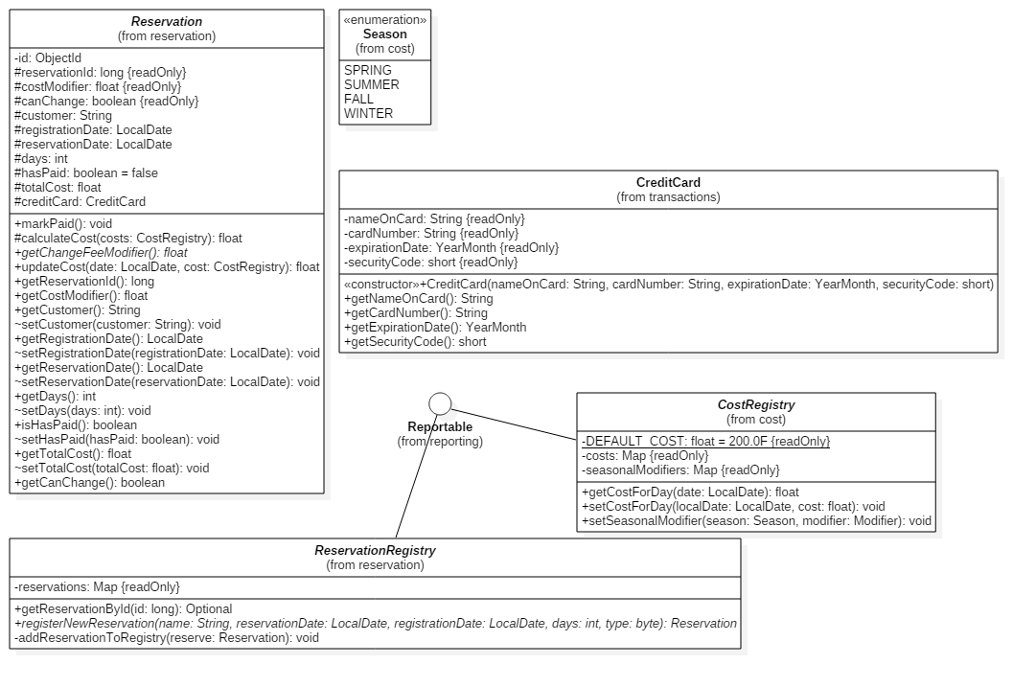

1

1

**Domain Model Review Checklist**

1. This design model contains the bulk of all significant classes that will be required for this system to work.
2. This model design does show important relationships where they exist.
3. These models are designed similar to real-world concepts, and accurately reflect relationships these real world items would have.
4. This model shows multiplicity constraints, such as the registries of which we only need one instance.
5. The classes shown are all enumerated/abstract classes intended to show relationships, without showing the particular implementations thereof.
6. All classes show the important and relevant attributes that are necessary for that class to function properly within the application context.
7. The class naming and attributes are simple and clear to understand.
8. The classes aren’t used as attributes types. Instead, a composite part relationship is indicated between them.
9. Classes do show operations, since the designs were ported straight from the Java classes. However, due the accelerated schedule of this project, this can be accepted.

**OOAD – Architectural Design**

**Type of System**

Ophelia’s Oasis in the Amlet desert hotel will use an *interactive* Hotel Management System (HMS) to meet all of the functional requirements outlined by the client. The interactive system is a fitting choice for this application, since it allows the actor to carry out a business process which consists of a relatively fixed sequence of actor requests and system responses. The interactive system is also a fitting choice, because it is relatively simple to design and implement, and is easily applied to client-server relationships.

**Architectural Style**

Ophelia’s Oasis in the Amlet desert hotel will use a *main program and subroutines* architectural style to implement its Hotel Management System which will look much like the one below.

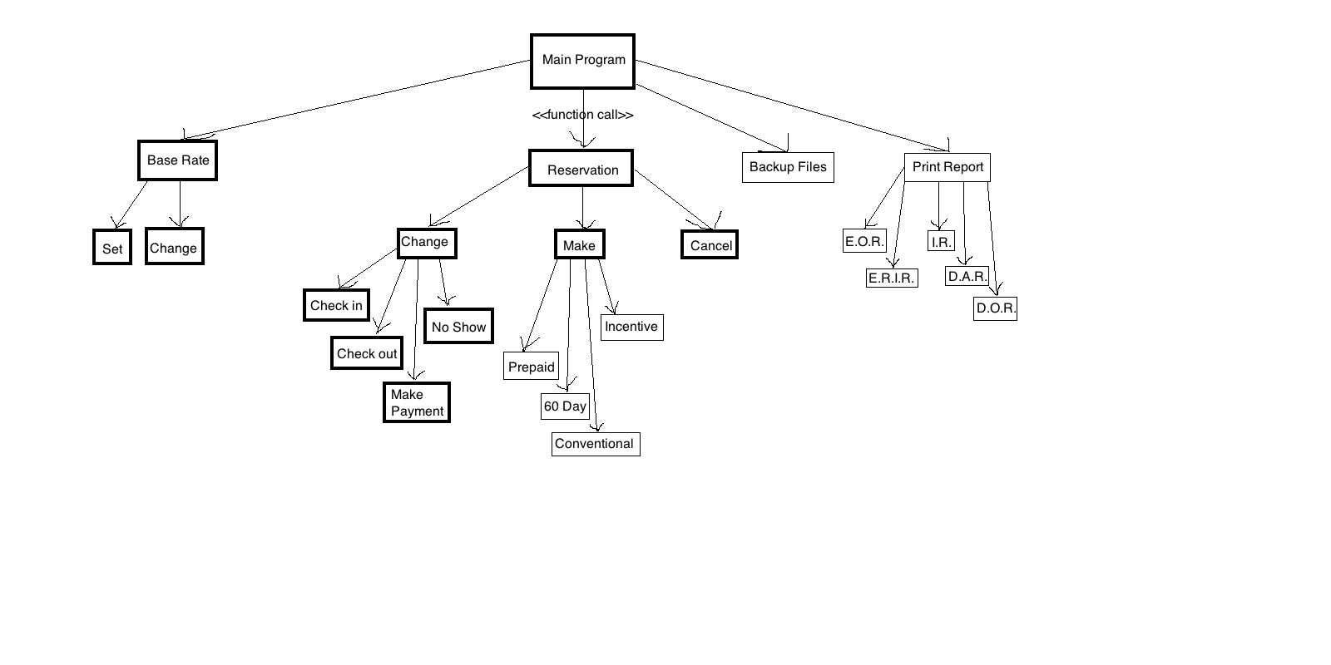

**Functionality and Interface**

As is shown in the above diagram, the engine that drives this system is the main program.  From the main program, once an employee or management interfaces with the system, the system invokes the appropriate subroutine to fulfill the functional requirement which was specified by the client.  The reservation is updated, or the report is printed (as examples), then the function exits and awaits the next user interaction.

      Interface with the system is made by employees and management only, as described in the functional requirements.  Guests contact the employees.  The employees interface with the system to perform the needed task in order to fulfill the appropriate functional requirement.  The system executes the appropriate task.  Then, the system exits once it has finished its performed task and awaits the next employee or management interface.

**Requirements-use case traceability matrix**

R = Requirements

P = Priority

UC = green

UC P = Use case priority

|  |  |  |  |  |  |  |  |  |  |  |  |  |  |  |  |  |  |  |  |  |
| --- | --- | --- | --- | --- | --- | --- | --- | --- | --- | --- | --- | --- | --- | --- | --- | --- | --- | --- | --- | --- |
| R | P | 1 | 2 | 3 | 4 | 5 | 6 | 7 | 8 | 9 | 10 | 11 | 12 | 13 | 14 | 15 | 16 | 17 | 18 | 19 |
| 1 | 1 | x |  |  |  |  |  |  |  |  |  |  |  |  |  |  |  |  |  |  |
| 2 | 1 | x |  |  |  |  |  |  |  |  |  |  |  |  |  |  |  |  |  |  |
| 3 | 1 | x |  |  |  |  |  |  |  |  |  |  |  |  |  |  |  |  |  |  |
| 4 | 1 |  | x | x | x | x |  |  |  |  |  |  |  |  |  |  |  |  |  |  |
| 5 | 3 |  |  |  |  |  | x |  |  |  |  |  |  |  |  |  |  |  |  |  |
| 6 | 3 |  |  |  |  |  |  | x |  |  |  |  |  |  |  |  |  |  |  |  |
| 7 | 1 |  |  |  |  |  |  |  | x |  |  |  |  |  |  |  |  |  |  |  |
| 8 | 1 |  |  |  |  |  |  |  |  | x | x |  |  |  |  |  |  |  |  |  |
| 9 | 1 |  |  |  |  |  |  |  |  |  |  | x |  |  |  |  |  |  |  |  |
| 10 | 3 |  |  |  |  |  |  |  |  |  |  |  | x |  |  |  |  |  |  |  |
| 11 | 4 |  |  |  |  |  |  |  |  |  |  |  |  | x |  |  |  |  |  |  |
| 12 | 5 |  |  |  |  |  |  |  |  |  |  |  |  |  | x | x | x | x | x | x |
| UC | P | 1 | 1 | 1 | 1 | 1 | 3 | 3 | 1 | 1 | 1 | 1 | 4 | 1 | 5 | 5 | 5 | 5 | 5 | 5 |

**High-level use cases**

**UC01.** Set the base rate

TUCBW management setting the current base rate for each room depending on the time of year and type of reservation.

TUCEW management receives confirmation.

**UC02.** Make prepaid reservation

TUCBW a staff member makes a prepaid reservation

TUCEW a staff member receives confirmation

**UC03.** Make 60-days in advance reservation

TUCBW a staff member makes a 60-days in advance reservation

TUCEW a staff member receives confirmation

**UC04.** Make conventional reservations

TUCBW a staff member makes a conventional reservation

TUCEW a staff member receives confirmation

**UC05.** Make incentive reservations

TUCBW a staff member makes an incentive reservation

TUCEW a staff member receives confirmation

**UC08.** Check in

TUCBW a staff member checks in a guest

TUCEW a staff member receive full payment and confirmation

**UC09.** Check out

TUCBW a staff member checks out a guest

TUCEW a staff member receive confirmation

**UC10.** Print accommodation bill

TUCBW a staff member access guest accommodation bill and clicks “print”

TUCEW a staff member receives the print accommodation bill

**UC11.** Accept payment

TUCBW a staff member receives guest credit card information

TUCEW a staff member receives confirmation of payment

**UC13.** Backup copy of all files

TUCBW a staff member clicks on “backup files”

TUCEW a staff member receives confirmation

**Derived use cases**

**UC01.** Set the base rate (Actor: Management, System: HMS)

**UC02.** Make prepaid reservation (Actor: Staff, System: HMS)

**UC03.** Make 60-days in advance reservation (Actor: Staff, System: HMS)

**UC04.** Make conventional reservations (Actor: Staff, System: HMS)

**UC05.** Make incentive reservations (Actor: Staff, System: HMS)

**UC06.** Cancel reservation (Actor: Staff, System: HMS)

**UC07.** Change reservation (Actor: Staff, System: HMS)

**UC08.** Check in (Actor: Staff, System: HMS)

**UC09.** Check out (Actor: Staff, System: HMS)

**UC10.** Print accommodation bill (Actor: Staff, System: HMS)

**UC11.** Accept payment (Actor: Staff, System: HMS)

**UC12.** Classify as no show (Actor: Staff, System: HMS)

**UC13.** Backup copy of all files(Actor: Staff, System: HMS)

**UC14.** Print expected occupancy reports (Actor: Management, System: HMS)

**UC15.** Print expected room income reports (Actor: Management, System: HMS)

**UC16.** Print incentive reports (Actor: Management, System: HMS)

**UC17.** Print daily arrivals reports (Actor: Staff, System: HMS)

**UC18.** Print daily occupancy reports (Actor: Staff, System: HMS)

**Use Case Diagram**

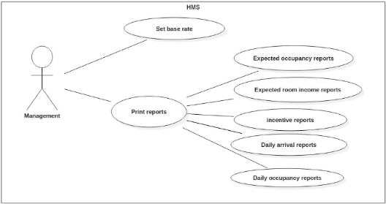

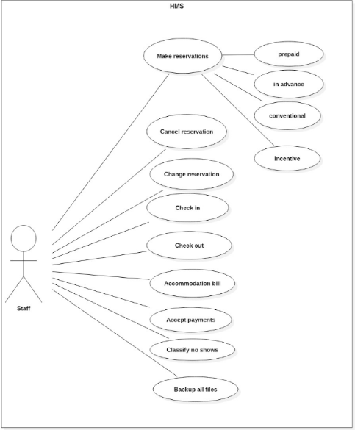

**UC01.** Set the base rate

|  |  |
| --- | --- |
| Precondition: Management must be logged in to the HMS. | |
| Actor: Management | System: HMS |
|  | 0. The system displays the main menu. |
| 1. TUCBW Management chooses, “Set base rate,” option. | 2. The system prompts management to enter an amount for the base rate. |
| 3. Management enters amount for base rate. | 4. *The system sets the base rate and displays confirmation message. |
| 5. TUCEW Mgt seeing the msg. |  |
| Postcondition: NONE | |

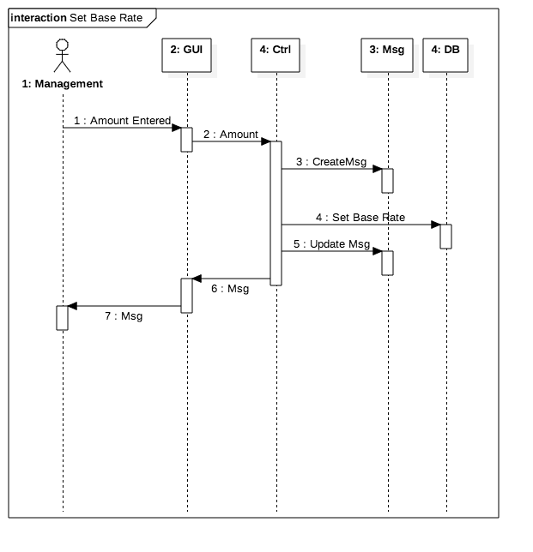

**UC01: DCD**

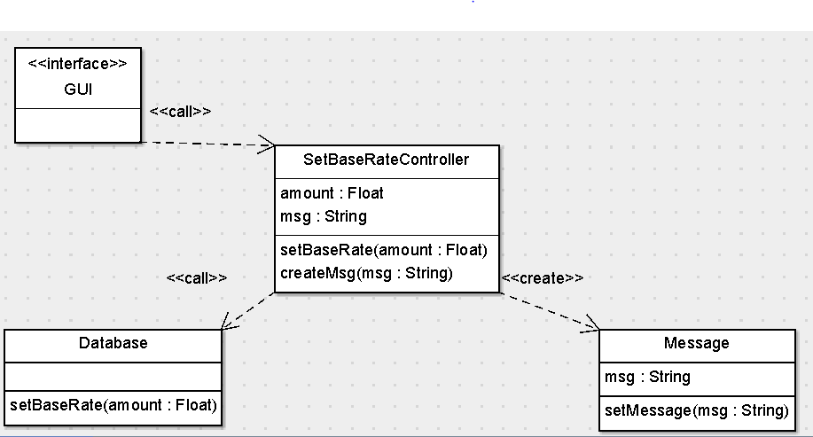

**UC02.** Make prepaid reservation

|  |  |
| --- | --- |
| Precondition: The staff member must have chosen Make Reservation from Main Menu. | |
| Actor: Staff | System: HMS |
|  | 1. HMS displays “Make Reservation.” |
| 1. TUCBW a staff member selects “Prepaid.” | 1. System prompts actor for guest information (i.e. name, CC, etc.) |
| 1. Staff inputs guest information. | 1. *HMS creates reservation and displays confirmation message. |
| 1. TUCEW a staff member receives confirmation. |  |
| Postcondition: NONE | |

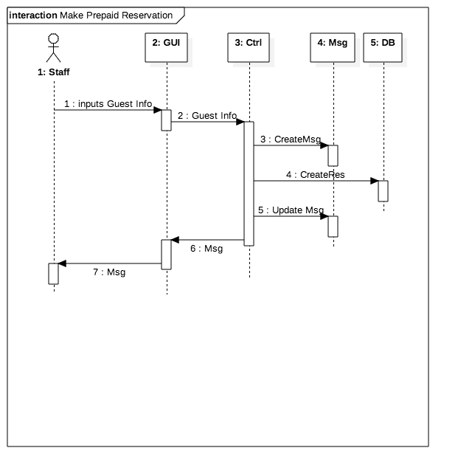

**UC02: DCD**

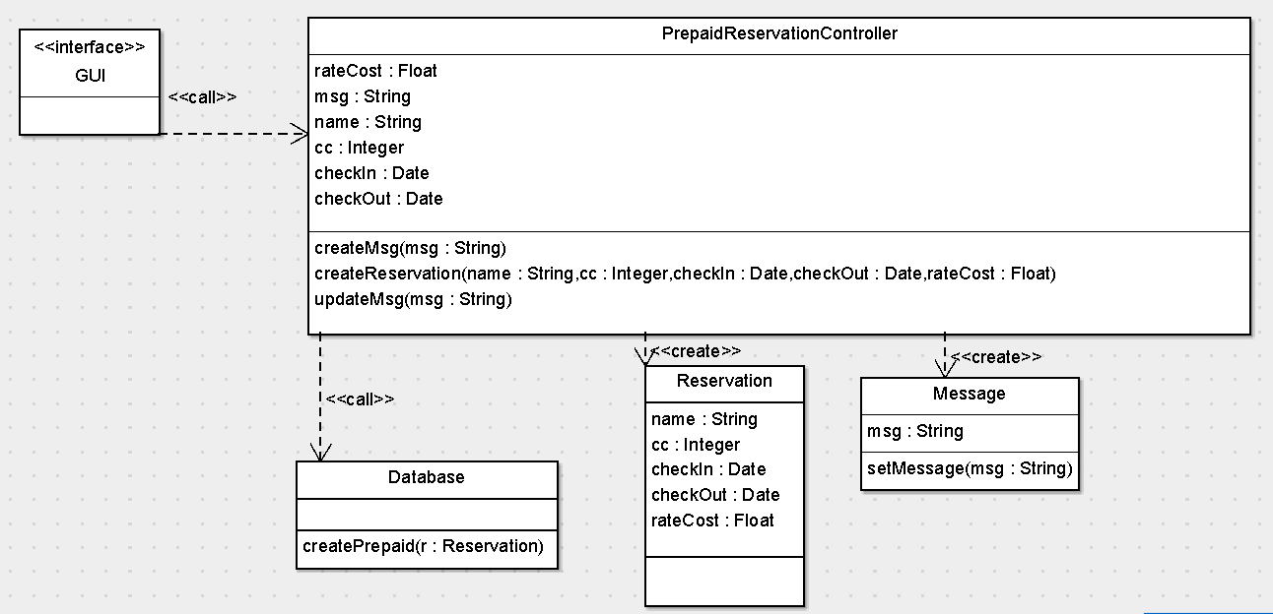

**UC03.** Make 60-days in advance reservation

|  |  |
| --- | --- |
| Precondition: The staff member has already chosen Make Reservation from Main Menu. | |
| Actor: Staff | System: HMS |
|  | 0. System displays the Make Reservation menu. |
| 1. TUCBW Staff chooses, “60-days in advance reservation,” option. | 2. System prompts Staff for guest’s information, i.e. credit card, name, etc. |
| 3. Staff enters information. | 4. *System creates reservation and displays confirmation message. |
| 5. TUCEW Staff receives confirmation. |  |
| Postcondition: NONE | |

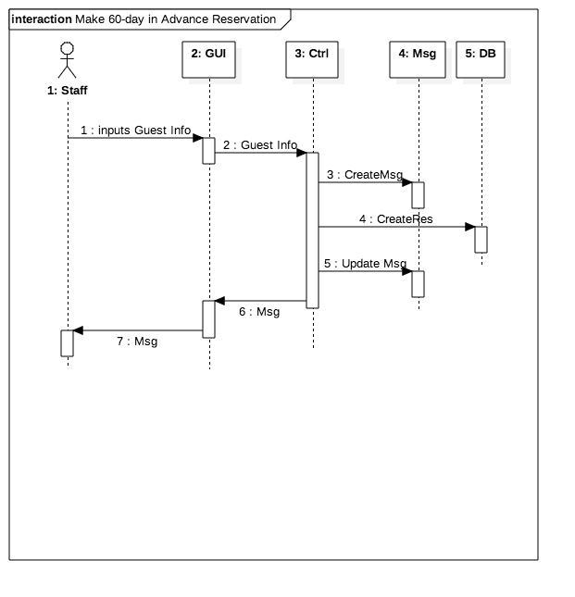

**UC03:DCD**

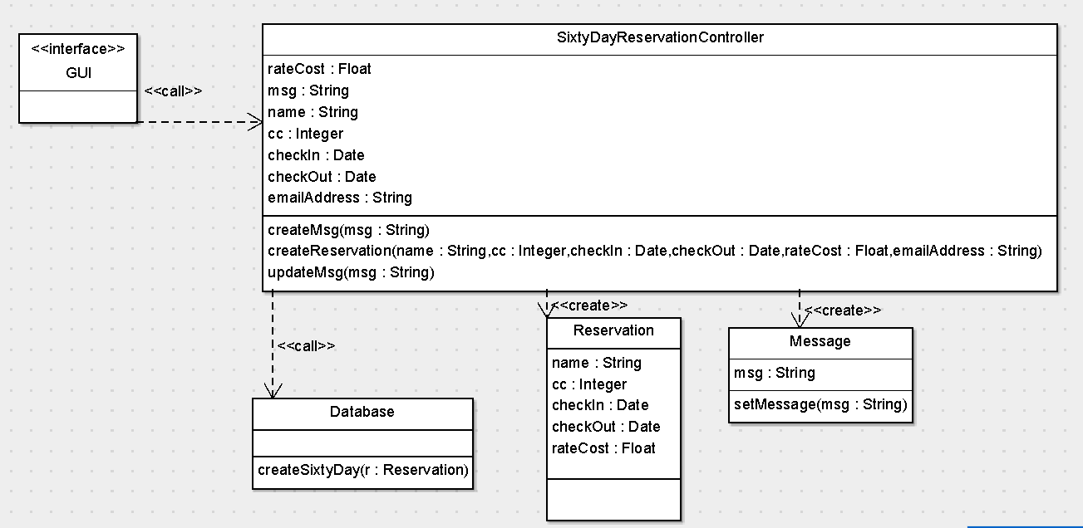

**UC04.** Make conventional reservations

|  |  |
| --- | --- |
| Precondition: The staff member must have chosen make reservation from Main Menu. | |
| Actor: Staff | System: HMS |
|  | 1. HMS displays “Make Reservation” |
| 1. TUCBW a staff member selects “Conventional.” | 1. System prompts for guest information i.e. credit card, name etc. |
| 1. Staff inputs guest information. | 1. *HMS creates reservation and displays confirmation message. |
| 1. TUCEW a staff member receives confirmation. |  |
| Postcondition: NONE | |

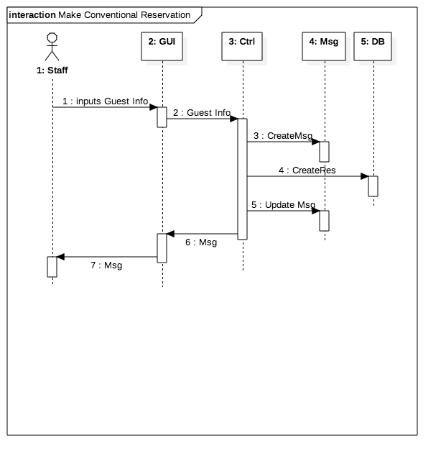

**UC04: DCD**

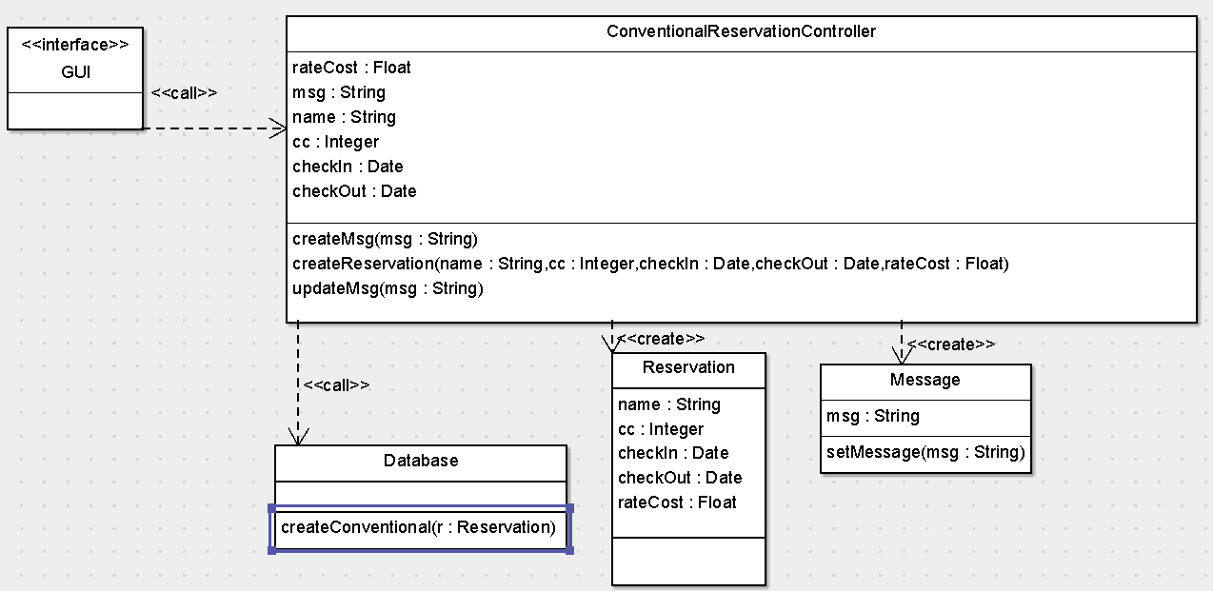

**UC05.** Make incentive reservations

|  |  |
| --- | --- |
| Precondition: The staff member has already chosen Make Reservation. | |
| Actor: Management | System: HMS |
|  | 0. System displays the Make Reservation menu. |
| 1. TUCBW Management chooses, “incentive reservation,” option. | 2. System prompts Staff for guest’s information, i.e. credit card, name, etc. |
| 3. Staff enters personal information. | 4. *System creates incentive reservation and displays confirmation message. |
| 5. TUCEW Staff receives confirmation. |  |
| Postcondition: NONE | |

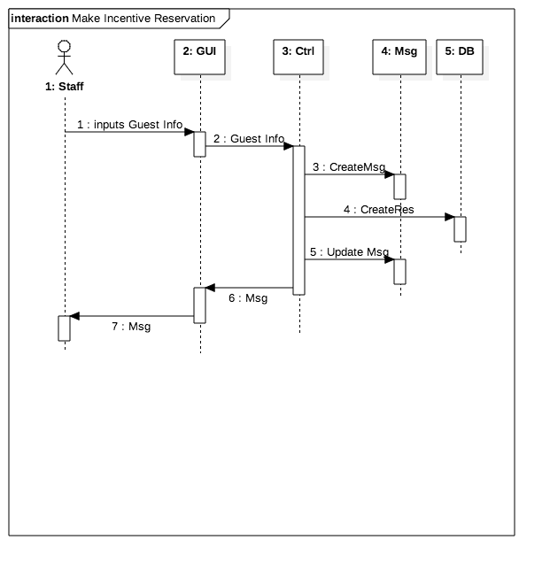

**UC05: DCD**

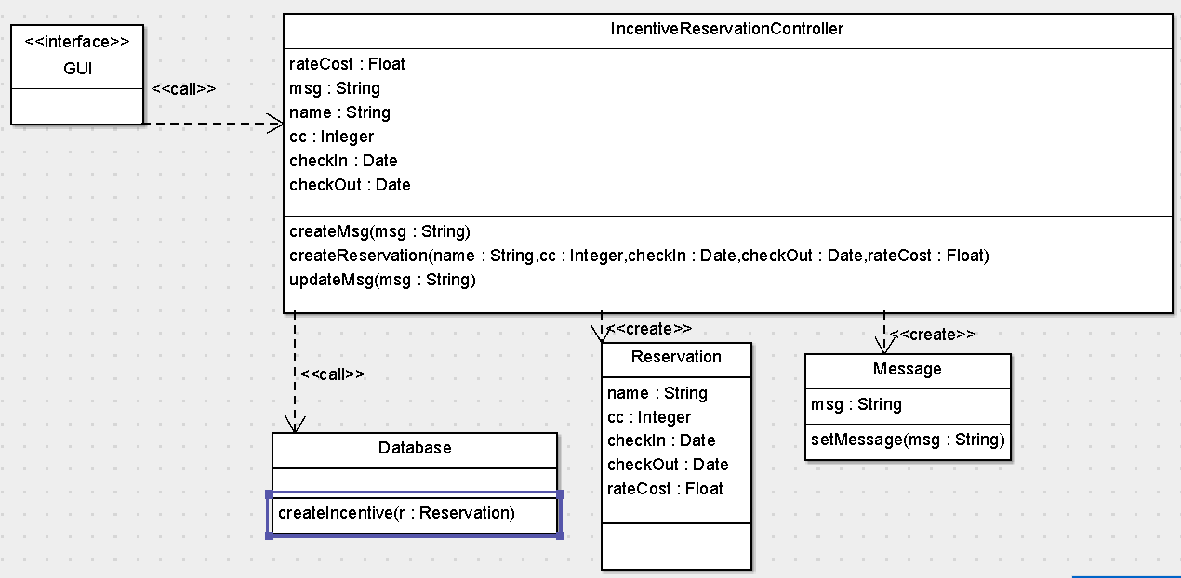

**UC06.** Cancel reservation

|  |  |
| --- | --- |
| Precondition: The staff member is logged in to the HMS. | |
| Actor: Management | System: HMS |
|  | 0. System displays the Main menu. |
| 1. TUCBW Staff chooses Cancel Reservation. | 2. System prompts Staff for guest’s personal information, i.e. credit card, name, etc. |
| 3. Staff enters personal information. | 4. *System cancels reservation and displays confirmation message. |
| 5. TUCEW Staff receives confirmation. |  |
| Postcondition: NONE | |

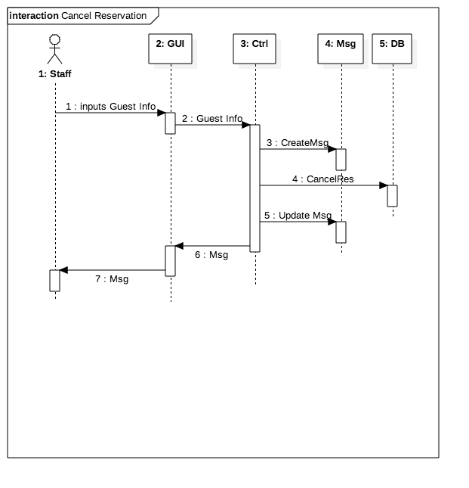

**UC06: DCD**

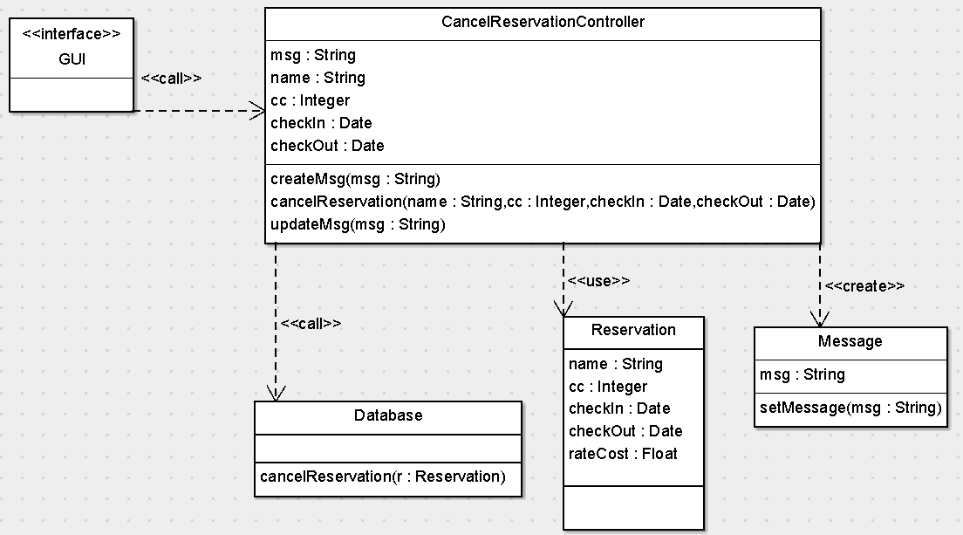

**UC07.** Change reservation

|  |  |
| --- | --- |
| Precondition: The staff member is logged in to the HMS. | |
| Actor: Management | System: HMS |
|  | 0. System displays the Main Menu. |
| 1. TUCBW Staff chooses, “Change Reservation,” option. | 2. System prompts Staff for guest’s information, i.e. credit card, name, etc. and change information. |
| 3. Staff enters information. | 4. *System changes the reservation and displays confirmation message. |
| 5. TUCEW Staff receives confirmation. |  |
| Postcondition: NONE | |

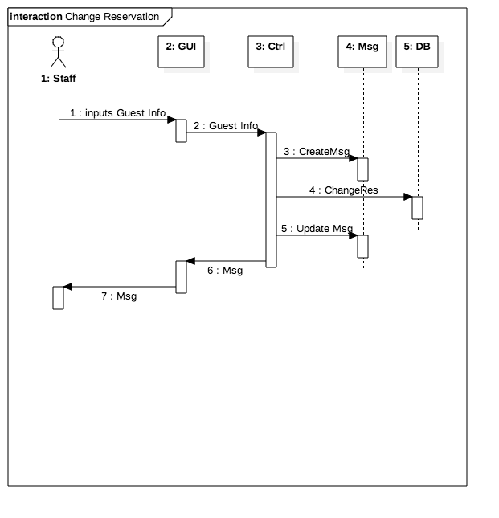

**UC07: DCD**

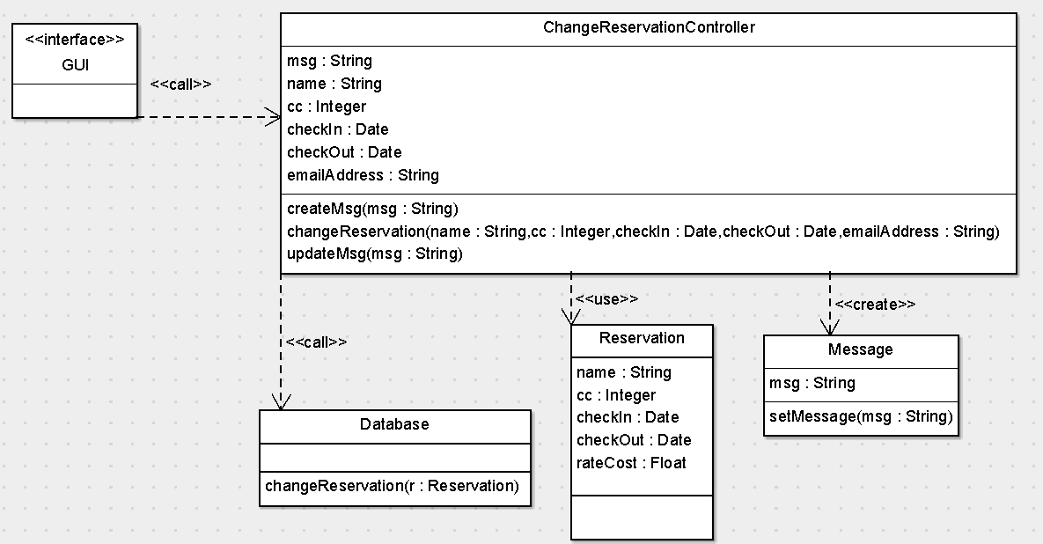

**UC08.** Check in

|  |  |
| --- | --- |
| Precondition: The staff member must have been logged in to HMS. | |
| Actor: Staff | System: HMS |
|  | 1. HMS displays main menu. |
| 1. TUCBW a staff member selects “Check in.” | 1. System prompts for guest information i.e. credit card, name etc. |
| 1. Staff inputs guest information. | 1. HMS displays reservation information. |
| 1. Staff member selects “confirm.” | 1. *HMS checks guest in and displays confirmation message. |
| 1. TUCEW a staff member receives confirmation. |  |
| Postcondition: NONE | |

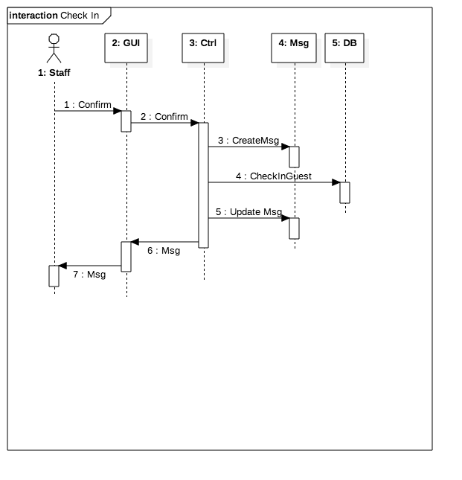

**UC08: DCD**

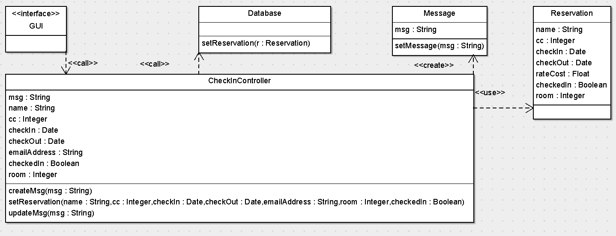

**UC09.** Check out

|  |  |
| --- | --- |
| Precondition: The staff member must have been logged in to HMS. | |
| Actor: Staff | System: HMS |
|  | 1. HMS displays main menu |
| 1. TUCBW a staff member selects “Check out.” | 1. System prompts for guest information i.e. credit card, name etc. |
| 1. Staff inputs guest information | 1. HMS displays reservation information |
| 1. Staff member selects “confirm” | 1. *HMS checks guest out and displays confirmation message. |
| 1. TUCEW a staff member receives confirmation. |  |
| Postcondition: NONE | |

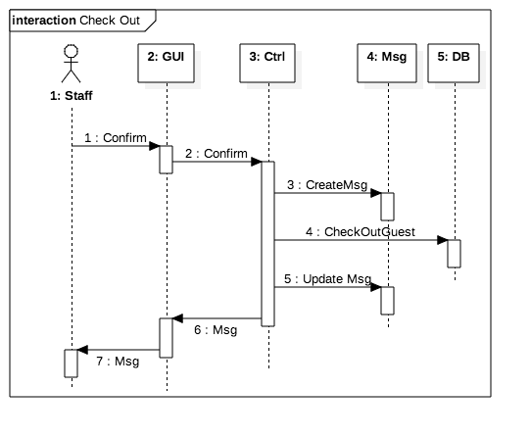

**UC09: DCD**

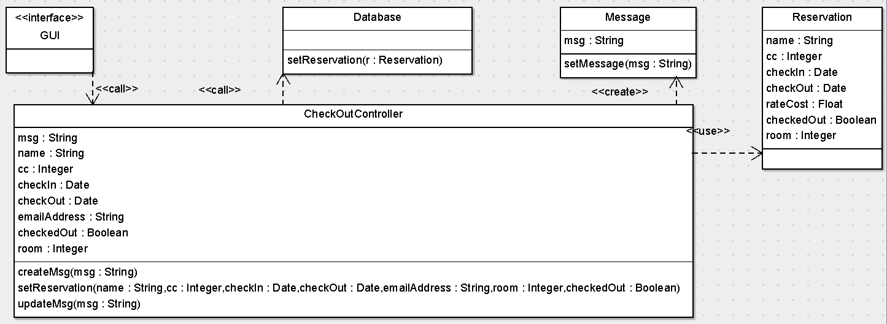

**UC10.** Print accommodation bill

|  |  |
| --- | --- |
| Precondition: The staff member must have logged in to HMS. | |
| Actor: Staff | System: HMS |
|  | 1. HMS displays main menu. |
| 1. TUCBW a staff member selects “Print accommodation bill.” | 1. System prompts for guest information i.e. credit card, name etc. |
| 1. Staff inputs guest information. | 1. *HMS displays accommodation bill. |
| 1. Staff member selects “Print” | 1. HMS prints bill. |
| 1. TUCEW a staff member receives printed accommodation bill. |  |
| Postcondition: NONE | |

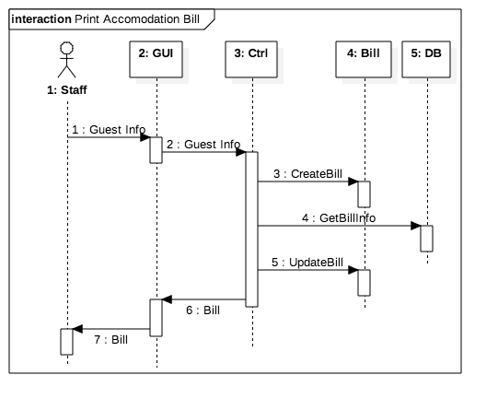

**UC10: DCD**

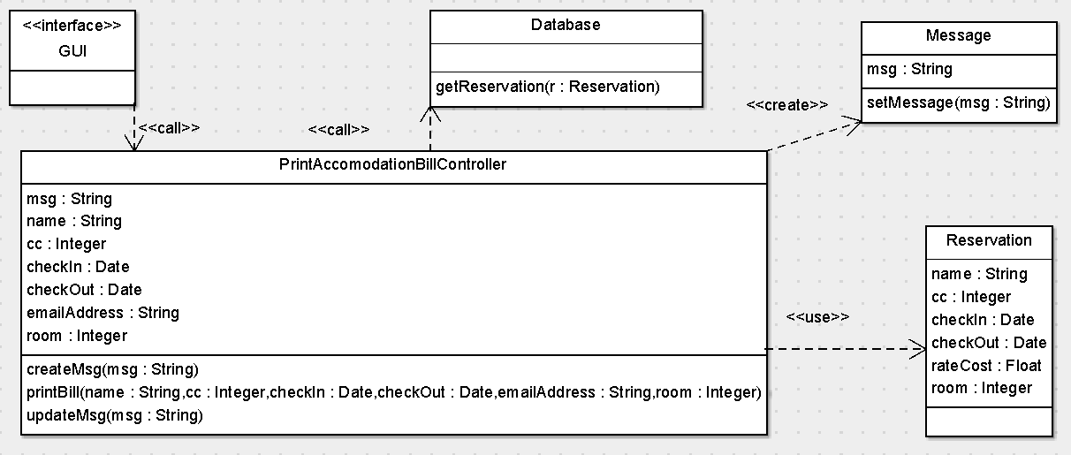

**UC11.** Accept payment

|  |  |
| --- | --- |
| Precondition: The staff member must have logged in to HMS. | |
| Actor: Staff | System: HMS |
|  | 1. HMS displays main menu |
| 1. TUCBW a staff member selects “Payment.” | 1. System prompts for credit card information. |
| 1. Staff inputs credit card information. | 1. *HMS applies payment and displays confirmation message. |
| 1. TUCEW a staff member receives confirmation of payment. |  |
| Postcondition: NONE | |

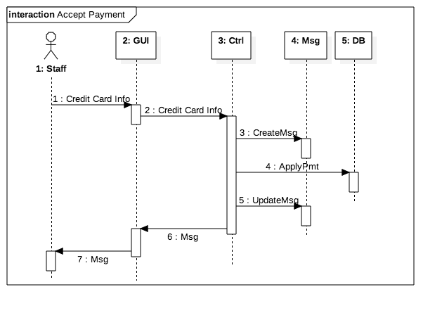

**UC11: DCD**

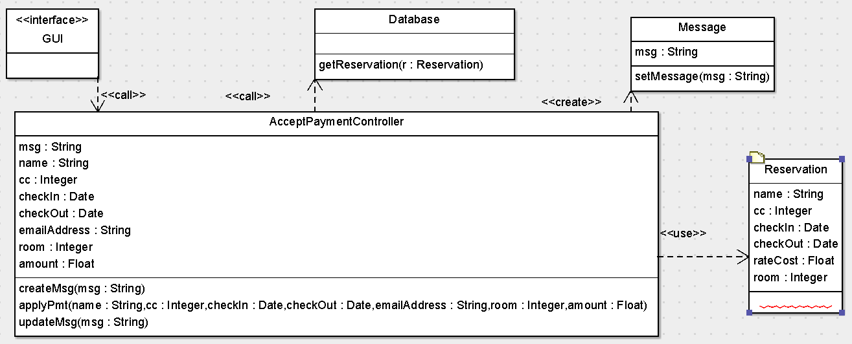

**UC12.** Classify as no show

|  |  |
| --- | --- |
| Precondition: The staff member must have logged in to HMS. | |
| Actor: Staff | System: HMS |
|  | 1. HMS displays main menu |
| 1. TUCBW a staff member selects “No Show.” | 1. System prompts actor for reservation information. |
| 1. Staff inputs reservation information. | 1. *HMS updates reservation and displays confirmation Msg. |
| 1. TUCEW staff receives confirmation. |  |
| Postcondition: NONE | |

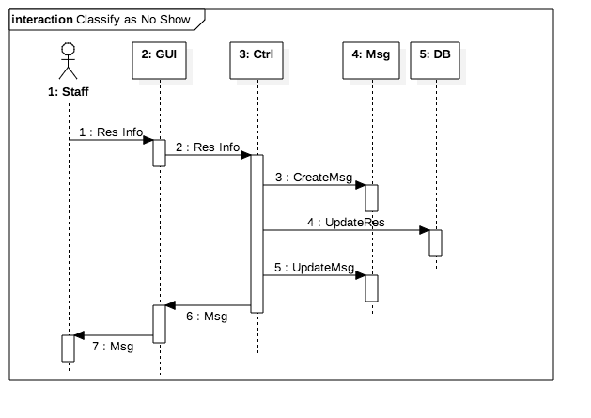

**UC12: DCD**

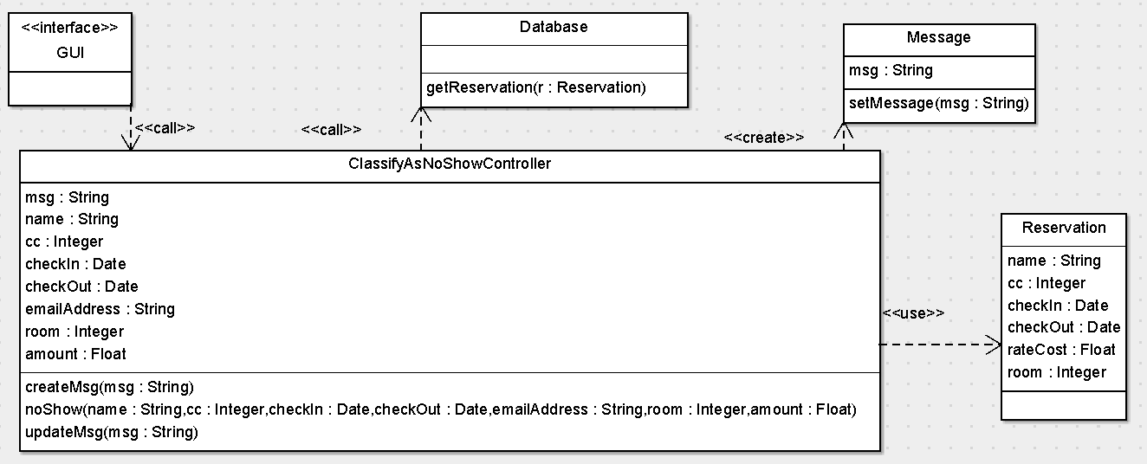

**UC13.** Backup copy of all files

|  |  |
| --- | --- |
| Precondition: The staff member must have logged in to HMS. | |
| Actor: Staff | System: HMS |
|  | 1. HMS displays main menu |
| 1. TUCBW a staff member selects “Backup Files.” | 1. *System backs up files and displays confirmation. |
| 1. TUCEW staff receives confirmation. |  |
| Postcondition: NONE | |

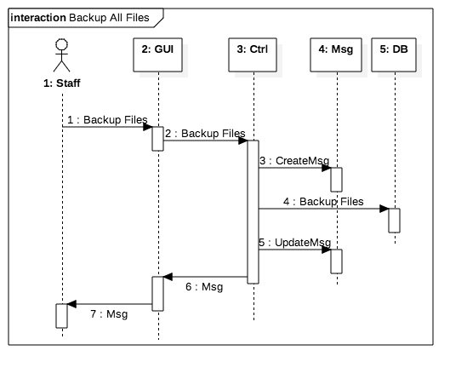

**UC13: DCD**

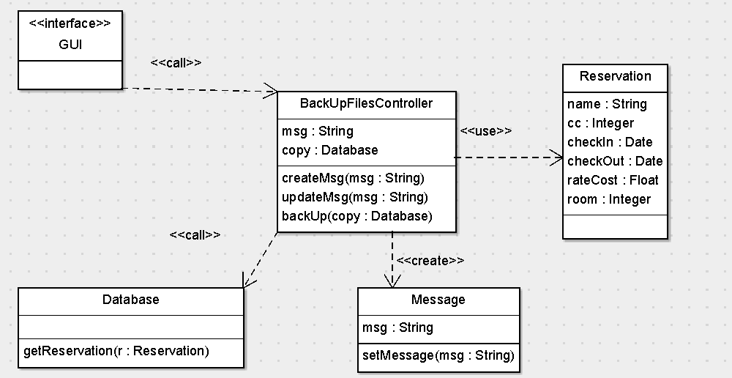

**UC14.** Print expected occupancy report

|  |  |
| --- | --- |
| Precondition: The Management must have logged in to HMS and chosen Print Reports. | |
| Actor: Management | System: HMS |
|  | 0. HMS displays Print Reports menu. |
| 1. TUCBW Management selects “Print Expectancy Report.” | 2. *System prints report. |
| 3. Management receives printed report. |  |
| Postcondition: NONE | |

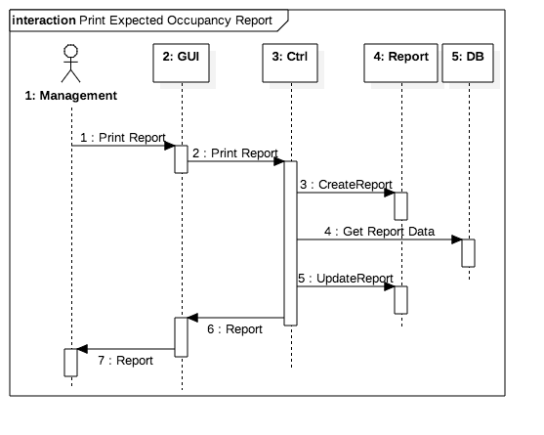

**UC14: DCD**

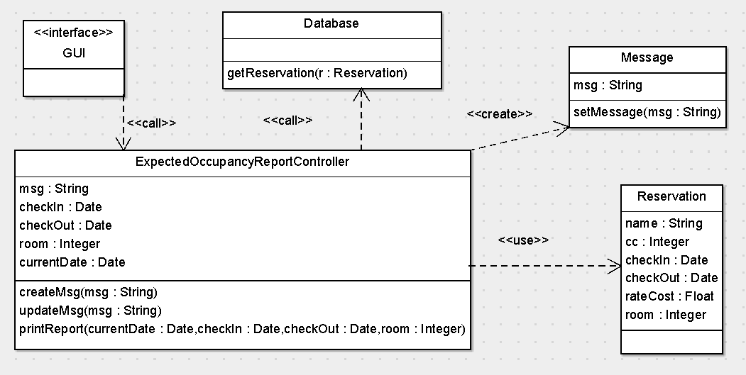

**UC15.** Print expected room income report

|  |  |
| --- | --- |
| Precondition: The Management must have logged in to HMS and chosen Print Reports. | |
| Actor: Management | System: HMS |
|  | 0. HMS displays Print Reports menu. |
| 1. TUCBW Management selects “Print Expected Room Income Report” | 2. *System prints report. |
| 3. Management receives printed report. |  |
| Postcondition: NONE | |

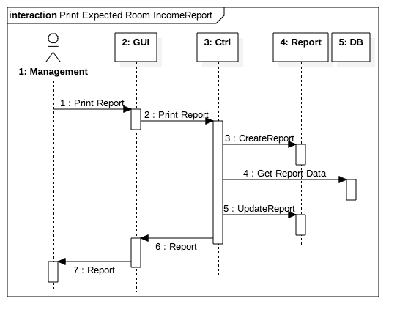

**UC15: DCD**

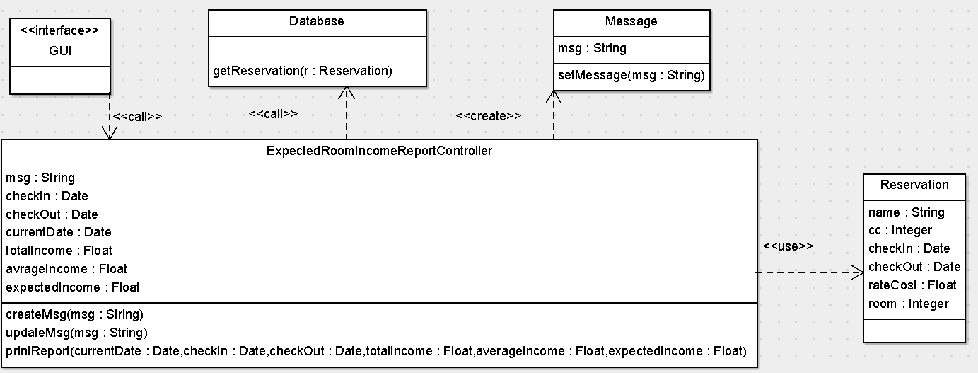

**UC16.** Print incentive report

|  |  |
| --- | --- |
| Precondition: The Management must have logged in to HMS and chosen Print Reports. | |
| Actor: Management | System: HMS |
|  | 0. HMS displays Print Reports menu. |
| 1. TUCBW Management selects “Print Incentive Report.” | 2. *System prints report. |
| 3. Management receives printed report. |  |
| Postcondition: NONE | |

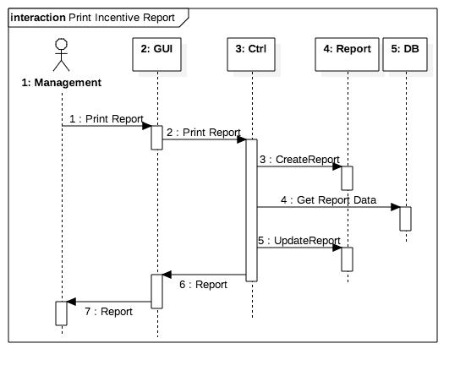

**UC16: DCD**

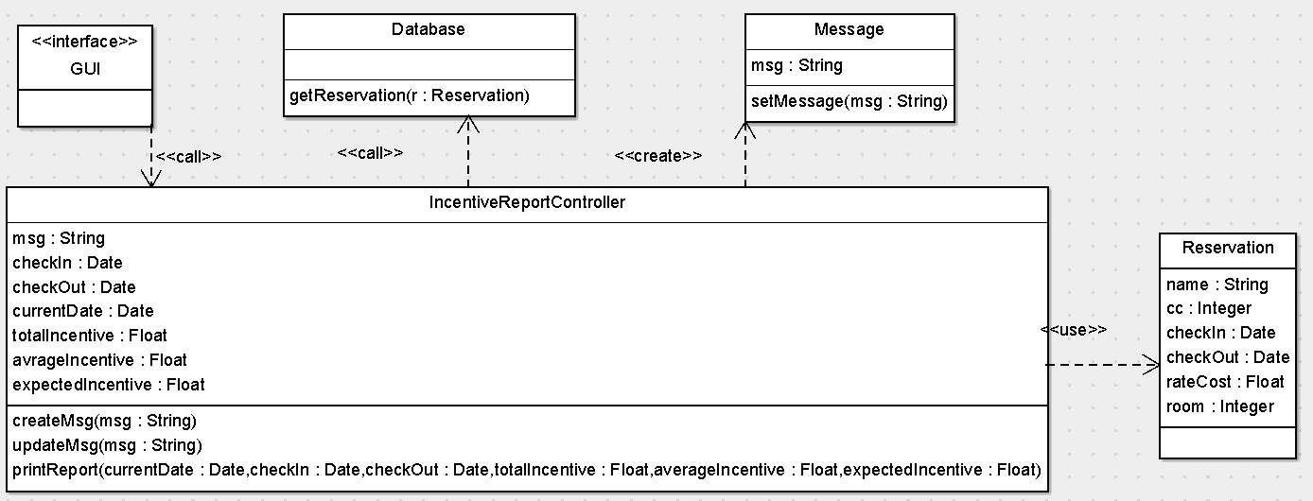

**UC17.** Print daily arrivals report

|  |  |
| --- | --- |
| Precondition: The Staff must have logged in to HMS and chosen Print Reports. | |
| Actor: Staff | System: HMS |
|  | 0. HMS displays Print Reports menu. |
| 1. TUCBW Staff selects “Print Expectancy Report.” | 2. *System prints report. |
| 3. Staff receives printed report. |  |
| Postcondition: NONE | |

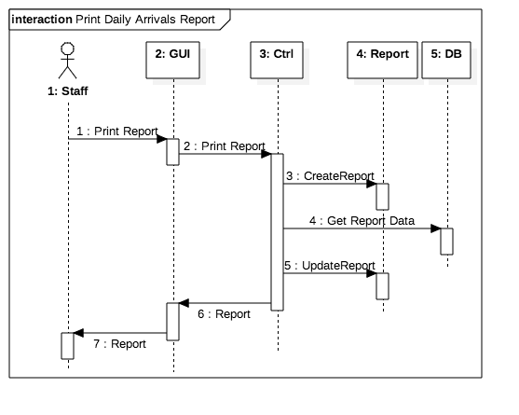

**UC17: DCD**

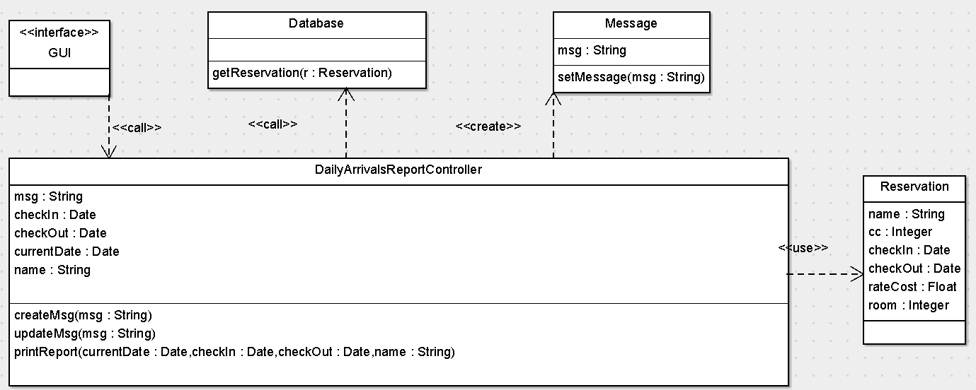

**UC18.** Print daily occupancy report

|  |  |
| --- | --- |
| Precondition: The Staff must have logged in to HMS and chosen Print Reports. | |
| Actor: Staff | System: HMS |
|  | 0. HMS displays Print Reports menu. |
| 1. TUCBW Staff selects “Print Daily Occupancy Report.” | 2. *System prints report. |
| 3. Staff receives printed report. |  |
| Postcondition: NONE | |

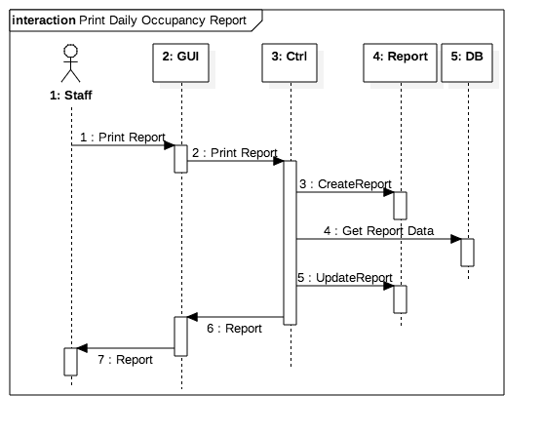

**UC18: DCD**

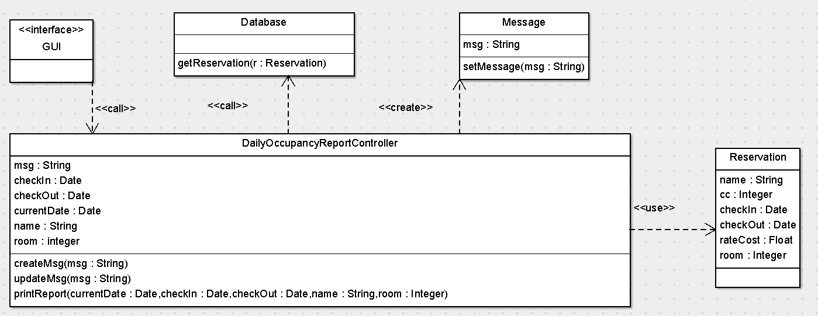

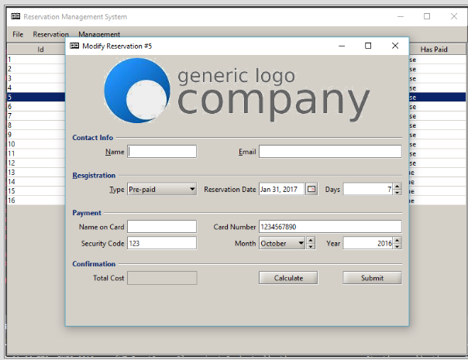

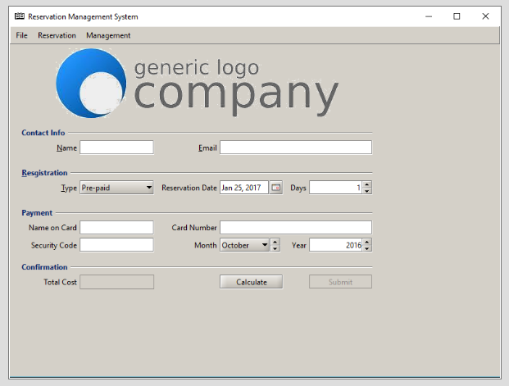

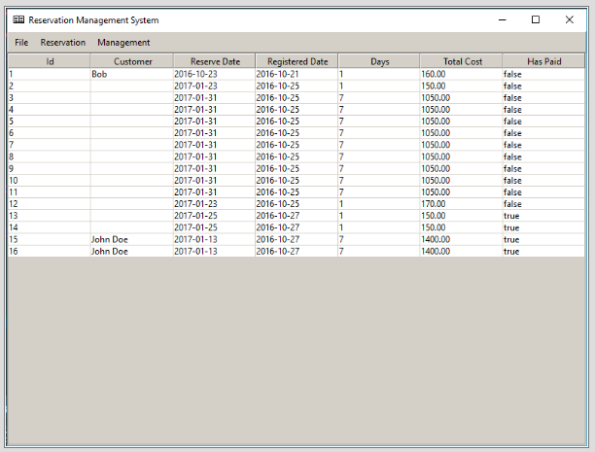

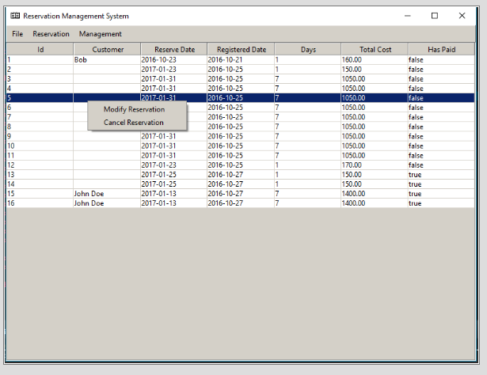

**UC13.** Backup copy of all files

Scenario: Backup All Files  
1. Staff selects “Backup Files”

2.1. GUI sends command to backUpFiles controller.

2.2. bakUpFiles controller creates a blank Msg.

2.3. backUpFiles controller saves all files in the database.

2.4. backUpFiles controller updates the Msg with, “Database Successfully Updated.”

2.5. else

2.5.1. backUpFiles controller writes, “Unsuccessful Backup.”

2.6. backUpFiles controller gives Msg to GUI.

2.7. GUI displays Msg to Staff.

Scenario Table

|  |  |  |  |  |
| --- | --- | --- | --- | --- |
| **#** | **Subject** | **Subject Action** | **Other Data / Objects** | **Object acted upon** |
| 1 | Staff | Selects | BackUpFiles | HMS GUI |
| 2.1 | GUI | Sends | BackUpFiles | BackUpFiles Ctrl |
| 2.2 | BackUpFiles Ctrl | Creates | Msg | BackUpFiles Ctrl |
| 2.3 | BackUpFiles Ctrl | Saves | All files | Database |
| 2.4 | BackUpFiles Ctrl | Updates | Msg | BackUpFiles Ctrl |
| 2.5 | Else | | | |
| 2.5.1 | BackUpFiles Ctrl | Writes | Msg | BackUpFiles Ctrl |
| 2.6 | BackUpFiles Ctrl | Gives | Msg | GUI |
| 2.7 | GUI | Displays | MSg | Staff |

**UC18.** Print daily occupancy report

Scenario: Print daily occupancy report  
1. Staff selects, “Print Daily Occupancy Report.”  
2.1. GUI sends command to dailyOccupancyReport (DOR) Controller.

2.2. dailyOccupancyReport Controller creates a blank Report.

2.3. for each guest currently staying at the hotel:

2.3.1. dailyOccupancyReport Controller adds the room number, guest name, date of departure if the   
 room was occupied the previous evening, and an asterisk if the guest is leaving that day to the   
 Report.

2.4. dailyOccupancyReport Controller prints the Report.

Scenario Table

|  |  |  |  |  |
| --- | --- | --- | --- | --- |
| **#** | **Subject** | **Subject Action** | **Other Data / Objects** | **Object acted upon** |
| 1 | Staff | Selects | Print Daily Occupancy Report | HMS GUI |
| 2.1 | GUI | Sends | Print Daily Occupancy Report | DOR Ctrl |
| 2.2 | DOR Ctrl | Creates | Report | DOR Ctrl |
| 2.3 | For each guest currently staying at the hotel: | | | |
| 2.3.1 | DOR Ctrl | Adds | Room#, Name, Dep date, * | Report |
| 2.4 | DOR Ctrl | Prints | Report | DOR Ctrl |

**Test Cases**

Fill in all the tables in the column of “Test Notes” with **Y** (passed), **N** (not passed), **N/A** (not available), or other textual notes.

**Add 60-Days-in-Advance Reservation**

1. Enter number days for reservation

|  |  |  |  |  |
| --- | --- | --- | --- | --- |
| **Test Case** | **Value Entered** | **Result** | **Comments** | **Pass** |
| Number too long (14 days) | 144 | Input impossible | Too many days | Y |
| User does not enter a number | [return] | Input impossible | At least one day needed | Y |
| User enters letters | Hi | Input impossible | Only digits | Y |
| Spaces entered | [5 spaces] | Input impossible | Atleast one digit needed | Y |

2. Enter arrival date

|  |  |  |  |  |
| --- | --- | --- | --- | --- |
| **Test Case** | **Value Entered** | **Result** | **Comments** | **Pass** |
| Date too long/short (10 chars – mm-dd-yyyy) | 123456 | Input impossible | Calendar provided | Y |
| User does not enter a value | [Enter] | Input impossible | Calendar provided | Y |
| User enters spaces | [5 spaces] | Input impossible | Calendar provided | Y |

3. Enter guest name

|  |  |  |  |  |
| --- | --- | --- | --- | --- |
| **Test Case** | **Value Entered** | **Result** | **Comments** | **Pass** |
| Guest Name too long (35 chars) | Asdfasdfhijklm  Nopqrstuvwxyz  Aabbccddeeffgg | Input possible | Create reservation | N |
| Enter spaces | [hit return] | Input possible | Create reservation | N |
| User does not enter letters | [two spaces] | Input impossible | Create reservation | Y |

4. Enter guest address

|  |  |  |  |  |
| --- | --- | --- | --- | --- |
| **Test Case** | **Value Entered** | **Result** | **Comments** | **Pass** |
| Address too long (75 chars) | Aaaaaaaaaaaa  Aaaaaaaaaaaa  Aaaaaaaaaaaa | Input possible | Creates reservation | N |
| User does not enter an address | [return] | Input possible | Creates reservation | N |
| User enters an address not appropriate | (3 spaces) | Input possible | Creates reservation | Y |
| User does not enter a street city state zip format for address | Atlanta GA | Input impossible | Creates reservation | Y |

5. Enter guest phone number

|  |  |  |  |  |
| --- | --- | --- | --- | --- |
| **Test Case** | **Value Entered** | **Result** | **Comments** | **Pass** |
| No phone number entered | [Enter] | Input impossible | Phone number needed | Y |
| Phone number entered longer/shorter than value | 11222222222 | Input impossible | Only 10 digits allowed | Y |
| Phone number entered as spaces | [5 Spaces] | Input impossible | Numbers automatically format | Y |
| Phone number entered in different way | ###-#### | Input impossible | Only numbers allowed | Y |

6. Enter any comments (optional)

|  |  |  |  |  |
| --- | --- | --- | --- | --- |
| **Test Case** | **Value Entered** | **Result** | **Comments** | **Pass** |
| No comments are entered | [Enter] | N/A | N/A | N/A |
| Comments entered are too long (100 chars) | CommentsCommentsComments  CommentsCommentsComments  …CommentsComments… | N/A | N/A | N/A |

7. Enter guest e-mail address

|  |  |  |  |  |
| --- | --- | --- | --- | --- |
| **Test Case** | **Value Entered** | **Result** | **Comments** | **Pass** |
| Email too long (40 chars) | Averylongemail  Addressgoeshere  Anditfails | Input Accepted | TextBox allows up to 40 chars | Y |
| User does not enter an email address | [return] | Input Accepted | Saves blank email | N |
| User enters an inappropriate email address | Several spaces | Input Impossible | Only chars, numbers and special chars allowed | Y |

**Update 60-Days-in-Advance Reservation**

1. Enter reservation type

|  |  |  |  |  |
| --- | --- | --- | --- | --- |
| **Test Case** | **Value Entered** | **Result** | **Comments** | **Pass** |
| Enter no value | [enter] | Input impossible | Automatically selected | Y |
| Enter value other than D, C, I, or P | Value not accepted | Input impossible | Drop down menu | Y |

2. Enter reservation ID

|  |  |  |  |  |
| --- | --- | --- | --- | --- |
| **Test Case** | **Value Entered** | **Result** | **Comments** | **Pass** |
| Does not enter ID | [return] | Input impossible | Automatically generated | Y |
| Reservation ID entered not in file | ID # | Input impossible | Automatically generated | Y |
| Reservation ID does not match reservation Type | Reservation number of different type | Impossible | Automatically generated | Y |
| ID number too long, not valid (9 digits) | 1234567890123 | Impossible | Automatically generated | Y |

3. Change reservation field

|  |  |  |  |  |
| --- | --- | --- | --- | --- |
| **Test Case** | **Value Entered** | **Result** | **Comments** | **Pass** |
| User does not enter a ‘y’es or ‘n’o | x | N/A | N/A | N/A |
| User does not enter a value | [Enter] | N/A | N/A | N/A |
| User enters in a value too long | Xx | N/A | N/A | N/A |

4. Change in number of days in reservation

|  |  |  |  |  |
| --- | --- | --- | --- | --- |
| **Test Case** | **Value Entered** | **Result** | **Comments** | **Pass** |
| User selects to enter different number of days for prepaid/60-day reservation | Not an Option for these two reservation Types | Possible | Changed reservation | N |
| User selects to change days for incentive/conventional | Different # of days | Possible | Changed reservation | Y |

5. Change in reservation dates

|  |  |  |  |  |
| --- | --- | --- | --- | --- |
| **Test Case** | **Value Entered** | **Result** | **Comments** | **Pass** |
| User selects to enter different dates | Different arrival date | Possible | Changed reservation | Y |
| Validate rates to reflect extra charges if prepaid/60-day reservation |  | Possible | Automatically generated | Y |

6. Enter credit card number

|  |  |  |  |  |
| --- | --- | --- | --- | --- |
| **Test Case** | **Value Entered** | **Result** | **Comments** | **Pass** |
| Credit card number with characters | 1289ajk909 | Impossible | Only digits allowed | Y |
| No value entered | [Enter] | Impossible | Only digits allowed | Y |
| User enters spaces | [5 spaces] | Impossible | Only digits allowed | Y |

7. Enter credit card expiration date

|  |  |  |  |  |
| --- | --- | --- | --- | --- |
| **Test Case** | **Value Entered** | **Result** | **Comments** | **Pass** |
| Date too long/short (10 digits) | 12-01-21231 | Impossible | Drop down box | Y |
| Month/day/year entered is invalid | 34-45-2002 | Impossible | Drop down box | Y |
| Day entered is not valid with the month entered | 02-30-2002 | Impossible | Drop down box | Y |
| User does not enter a value | [return] | Impossible | Drop down box | Y |
| User enters a value with previous year | 12-2003 | Impossible | Only dates pass the current | Y |
| User enters in previous month of current year | 01-2003 | Impossible | Only months equal or pass current | Y |

8. Enter credit card type

|  |  |  |  |  |
| --- | --- | --- | --- | --- |
| **Test Case** | **Value Entered** | **Result** | **Comments** | **Pass** |
| Type too long (15 char) | American Express Corporate | Impossible | Cannot input cc number | Y |
| User enters spaces | [5 spaces] | impossible | Cannot input cc number | Y |
| User does not enter a value | [Enter] | possible | Cannot input cc number | Y |

9. Enter amount bill paid

|  |  |  |  |  |
| --- | --- | --- | --- | --- |
| **Test Case** | **Value Entered** | **Result** | **Comments** | **Pass** |
| Value contains letters/characters | $aj.kj | N/A | N/A | N/A |
| No value entered | [Enter] | N/A | N/A | N/A |
| Spaces entered | [5 spaces] | N/A | N/A | N/A |

10. Enter date bill paid

|  |  |  |  |  |
| --- | --- | --- | --- | --- |
| **Test Case** | **Value Entered** | **Result** | **Comments** | **Pass** |
| Date too long/short (10 digits) | 12-01-21231 | Impossible | 16 digits must be entered | Y |
| Month/day/year entered is invalid | 34-45-2002 | Impossible | Set calendar | Y |
| Day entered is not valid with the month entered | 02-30-2002 | Impossible | Set calendar | Y |

**Add Conventional Reservation**

1. Enter number days for reservation

|  |  |  |  |  |
| --- | --- | --- | --- | --- |
| **Test Case** | **Value Entered** | **Result** | **Comments** | **Pass** |
| Number too long (14 days) | 144 | Input impossible | Too many days | Y |
| User does not enter a number | [return] | Input impossible | At least one day needed | Y |
| User enters letters | Hi | Input impossible | Only digits | Y |
| Spaces entered | [5 spaces] | Input impossible | Atleast one digit needed | Y |

2. Enter arrival date

|  |  |  |  |  |
| --- | --- | --- | --- | --- |
| **Test Case** | **Value Entered** | **Result** | **Comments** | **Pass** |
| Date too long/short (10 chars – mm-dd-yyyy) | 123456 | Input impossible | Calendar provided | Y |
| User does not enter a value | [Enter] | Input impossible | Calendar provided | Y |
| User enters spaces | [5 spaces] | Input impossible | Calendar provided | Y |

3. Enter guest name

|  |  |  |  |  |
| --- | --- | --- | --- | --- |
| **Test Case** | **Value Entered** | **Result** | **Comments** | **Pass** |
| Guest Name too long (35 chars) | Asdfasdfhijklm  Nopqrstuvwxyz  Aabbccddeeffgg | Input possible | Create reservation | N |
| Enter spaces | [hit return] | Input possible | Create reservation | N |
| User does not enter letters | [two spaces] | Input impossible | Create reservation | Y |

4. Enter guest address

|  |  |  |  |  |
| --- | --- | --- | --- | --- |
| **Test Case** | **Value Entered** | **Result** | **Comments** | **Pass** |
| Address too long (75 chars) | Aaaaaaaaaaaa  Aaaaaaaaaaaa  Aaaaaaaaaaaa | Input possible | Creates reservation | N |
| User does not enter an address | [return] | Input possible | Creates reservation | N |
| User enters an address not appropriate | (3 spaces) | Input possible | Creates reservation | Y |

5. Enter guest phone number

|  |  |  |  |  |
| --- | --- | --- | --- | --- |
| **Test Case** | **Value Entered** | **Result** | **Comments** | **Pass** |
| No phone number entered | [Enter] | Input impossible | Phone number needed | Y |
| Phone number entered longer/shorter than value | 11222222222 | Input impossible | Only 10 digits allowed | Y |
| Phone number entered as spaces | [5 Spaces] | Input impossible | Numbers automatically format | Y |
| Phone number entered in different way | ###-#### | Input impossible | Only numbers allowed | Y |

6. Enter any comments (optional)

|  |  |  |  |  |
| --- | --- | --- | --- | --- |
| **Test Case** | **Value Entered** | **Result** | **Comments** | **Pass** |
| No comments are entered | [Enter] | N/A | N/A | N/A |
| Comments entered are too long (100 chars) | CommentsCommentsComments  CommentsCommentsComments  …CommentsComments… | N/A | N/A | N/A |

7. Enter credit card number

|  |  |  |  |  |
| --- | --- | --- | --- | --- |
| **Test Case** | **Value Entered** | **Result** | **Comments** | **Pass** |
| Credit card number with characters | 1289ajk909 | Impossible | Only digits allowed | Y |
| No value entered | [Enter] | Impossible | Only digits allowed | Y |
| User enters spaces | [5 spaces] | Impossible | Only digits allowed | Y |

8. Enter credit card expiration date

|  |  |  |  |  |
| --- | --- | --- | --- | --- |
| **Test Case** | **Value Entered** | **Result** | **Comments** | **Pass** |
| Date too long/short (10 digits) | 12-01-21231 | Impossible | Drop down box | Y |
| Month/day/year entered is invalid | 34-45-2002 | Impossible | Drop down box | Y |
| Day entered is not valid with the month entered | 02-30-2002 | Impossible | Drop down box | Y |
| User does not enter a value | [return] | Impossible | Drop down box | Y |
| User enters a value with previous year | 12-2003 | Impossible | Only dates pass the current | Y |
| User enters in previous month of current year | 01-2003 | Impossible | Only months equal or pass current | Y |

9. Enter credit card type

|  |  |  |  |  |
| --- | --- | --- | --- | --- |
| **Test Case** | **Value Entered** | **Result** | **Comments** | **Pass** |
| Type too long (15 char) | American Express Corporate | Impossible | Cannot input cc number | Y |
| User enters spaces | [5 spaces] | impossible | Cannot input cc number | Y |
| User does not enter a value | [Enter] | possible | Cannot input cc number | Y |

As previously.

**Update Conventional Reservation**

1. Enter reservation type

|  |  |  |  |  |
| --- | --- | --- | --- | --- |
| **Test Case** | **Value Entered** | **Result** | **Comments** | **Pass** |
| Enter no value | [enter] | Input impossible | Automatically selected | Y |
| Enter value other than D, C, I, or P | Value not accepted | Input impossible | Drop down menu | Y |

2. Enter reservation ID

|  |  |  |  |  |
| --- | --- | --- | --- | --- |
| **Test Case** | **Value Entered** | **Result** | **Comments** | **Pass** |
| Does not enter ID | [return] | Input impossible | Automatically generated | Y |
| Reservation ID entered not in file | ID # | Input impossible | Automatically generated | Y |
| Reservation ID does not match reservation Type | Reservation number of different type | Impossible | Automatically generated | Y |
| ID number too long, not valid (9 digits) | 1234567890123 | Impossible | Automatically generated | Y |

3. Change reservation field

|  |  |  |  |  |
| --- | --- | --- | --- | --- |
| **Test Case** | **Value Entered** | **Result** | **Comments** | **Pass** |
| User does not enter a ‘y’es or ‘n’o | x | N/A | N/A | N/A |
| User does not enter a value | [Enter] | N/A | N/A | N/A |
| User enters in a value too long | Xx | N/A | N/A | N/A |

4. Change in number of days in reservation

|  |  |  |  |  |
| --- | --- | --- | --- | --- |
| **Test Case** | **Value Entered** | **Result** | **Comments** | **Pass** |
| User selects to enter different number of days for prepaid/60-day reservation | Not an Option for these two reservation Types | Possible | Changed reservation | N |
| User selects to change days for incentive/conventional | Different # of days | Possible | Changed reservation | Y |

5. Change in reservation dates

|  |  |  |  |  |
| --- | --- | --- | --- | --- |
| **Test Case** | **Value Entered** | **Result** | **Comments** | **Pass** |
| User selects to enter different dates | Different arrival date | Possible | Changed reservation | Y |
| Validate rates to reflect extra charges if prepaid/60-day reservation |  | Possible | Automatically generated | Y |

6. Enter amount bill paid

|  |  |  |  |  |
| --- | --- | --- | --- | --- |
| **Test Case** | **Value Entered** | **Result** | **Comments** | **Pass** |
| Value contains letters/characters | $aj.kj | N/A | N/A | N/A |
| No value entered | [Enter] | N/A | N/A | N/A |
| Spaces entered | [5 spaces] | N/A | N/A | N/A |

7. Enter date bill paid

|  |  |  |  |  |
| --- | --- | --- | --- | --- |
| **Test Case** | **Value Entered** | **Result** | **Comments** | **Pass** |
| Date too long/short (10 digits) | 12-01-21231 | Impossible | 16 digits must be entered | Y |
| Month/day/year entered is invalid | 34-45-2002 | Impossible | Set calendar | Y |
| Day entered is not valid with the month entered | 02-30-2002 | Impossible | Set calendar | Y |

As previously.

**Add Incentive Reservation**

1. Enter number days for reservation

|  |  |  |  |  |
| --- | --- | --- | --- | --- |
| **Test Case** | **Value Entered** | **Result** | **Comments** | **Pass** |
| Number too long (14 days) | 144 | Input impossible | Too many days | Y |
| User does not enter a number | [return] | Input impossible | At least one day needed | Y |
| User enters letters | Hi | Input impossible | Only digits | Y |
| Spaces entered | [5 spaces] | Input impossible | Atleast one digit needed | Y |

2. Enter arrival date

|  |  |  |  |  |
| --- | --- | --- | --- | --- |
| **Test Case** | **Value Entered** | **Result** | **Comments** | **Pass** |
| Date too long/short (10 chars – mm-dd-yyyy) | 123456 | Input impossible | Calendar provided | Y |
| User does not enter a value | [Enter] | Input impossible | Calendar provided | Y |
| User enters spaces | [5 spaces] | Input impossible | Calendar provided | Y |

3. Enter guest name

|  |  |  |  |  |
| --- | --- | --- | --- | --- |
| **Test Case** | **Value Entered** | **Result** | **Comments** | **Pass** |
| Guest Name too long (35 chars) | Asdfasdfhijklm  Nopqrstuvwxyz  Aabbccddeeffgg | Input possible | Create reservation | N |
| Enter spaces | [hit return] | Input possible | Create reservation | N |
| User does not enter letters | [two spaces] | Input impossible | Create reservation | Y |

4. Enter guest address

|  |  |  |  |  |
| --- | --- | --- | --- | --- |
| **Test Case** | **Value Entered** | **Result** | **Comments** | **Pass** |
| Address too long (75 chars) | Aaaaaaaaaaaa  Aaaaaaaaaaaa  Aaaaaaaaaaaa | Input possible | Creates reservation | N |
| User does not enter an address | [return] | Input possible | Creates reservation | N |
| User enters an address not appropriate | (3 spaces) | Input possible | Creates reservation | Y |
| User does not enter a street city state zip format for address | Atlanta GA | Input impossible | Creates reservation | Y |

5. Enter guest phone number

|  |  |  |  |  |
| --- | --- | --- | --- | --- |
| **Test Case** | **Value Entered** | **Result** | **Comments** | **Pass** |
| No phone number entered | [Enter] | Input impossible | Phone number needed | Y |
| Phone number entered longer/shorter than value | 11222222222 | Input impossible | Only 10 digits allowed | Y |
| Phone number entered as spaces | [5 Spaces] | Input impossible | Numbers automatically format | Y |
| Phone number entered in different way | ###-#### | Input impossible | Only numbers allowed | Y |

6. Enter any comments (optional)

|  |  |  |  |  |
| --- | --- | --- | --- | --- |
| **Test Case** | **Value Entered** | **Result** | **Comments** | **Pass** |
| No comments are entered | [Enter] | N/A | N/A | N/A |
| Comments entered are too long (100 chars) | CommentsCommentsComments  CommentsCommentsComments  …CommentsComments… | N/A | N/A | N/A |

7. Enter guest e-mail address

|  |  |  |  |  |
| --- | --- | --- | --- | --- |
| **Test Case** | **Value Entered** | **Result** | **Comments** | **Pass** |
| Email too long (40 chars) | Averylongemail  Addressgoeshere  Anditfails | Input Accepted | TextBox allows up to 40 chars | Y |
| User does not enter an email address | [return] | Input Accepted | Saves blank email | N |
| User enters an inappropriate email address | Several spaces | Input Impossible | Only chars, numbers and special chars allowed | Y |

As previously.

**Update Incentive Reservation**

1. Enter reservation type

|  |  |  |  |  |
| --- | --- | --- | --- | --- |
| **Test Case** | **Value Entered** | **Result** | **Comments** | **Pass** |
| Enter no value | [enter] | Input impossible | Automatically selected | Y |
| Enter value other than D, C, I, or P | Value not accepted | Input impossible | Drop down menu | Y |

2. Enter reservation ID

|  |  |  |  |  |
| --- | --- | --- | --- | --- |
| **Test Case** | **Value Entered** | **Result** | **Comments** | **Pass** |
| Does not enter ID | [return] | Input impossible | Automatically generated | Y |
| Reservation ID entered not in file | ID # | Input impossible | Automatically generated | Y |
| Reservation ID does not match reservation Type | Reservation number of different type | Impossible | Automatically generated | Y |
| ID number too long, not valid (9 digits) | 1234567890123 | Impossible | Automatically generated | Y |

3. Change reservation field

|  |  |  |  |  |
| --- | --- | --- | --- | --- |
| **Test Case** | **Value Entered** | **Result** | **Comments** | **Pass** |
| User does not enter a ‘y’es or ‘n’o | x | N/A | N/A | N/A |
| User does not enter a value | [Enter] | N/A | N/A | N/A |
| User enters in a value too long | Xx | N/A | N/A | N/A |

4. Change in number of days in reservation

|  |  |  |  |  |
| --- | --- | --- | --- | --- |
| **Test Case** | **Value Entered** | **Result** | **Comments** | **Pass** |
| User selects to enter different number of days for prepaid/60-day reservation | Not an Option for these two reservation Types | Possible | Changed reservation | N |
| User selects to change days for incentive/conventional | Different # of days | Possible | Changed reservation | Y |

5. Change in reservation dates

|  |  |  |  |  |
| --- | --- | --- | --- | --- |
| **Test Case** | **Value Entered** | **Result** | **Comments** | **Pass** |
| User selects to enter different dates | Different arrival date | Possible | Changed reservation | Y |
| Validate rates to reflect extra charges if prepaid/60-day reservation |  | Possible | Automatically generated | Y |

6. Enter credit card number

|  |  |  |  |  |
| --- | --- | --- | --- | --- |
| **Test Case** | **Value Entered** | **Result** | **Comments** | **Pass** |
| Credit card number with characters | 1289ajk909 | Impossible | Only digits allowed | Y |
| No value entered | [Enter] | Impossible | Only digits allowed | Y |
| User enters spaces | [5 spaces] | Impossible | Only digits allowed | Y |

7. Enter credit card expiration date

|  |  |  |  |  |
| --- | --- | --- | --- | --- |
| **Test Case** | **Value Entered** | **Result** | **Comments** | **Pass** |
| Date too long/short (10 digits) | 12-01-21231 | Impossible | Drop down box | Y |
| Month/day/year entered is invalid | 34-45-2002 | Impossible | Drop down box | Y |
| Day entered is not valid with the month entered | 02-30-2002 | Impossible | Drop down box | Y |
| User does not enter a value | [return] | Impossible | Drop down box | Y |
| User enters a value with previous year | 12-2003 | Impossible | Only dates pass the current | Y |
| User enters in previous month of current year | 01-2003 | Impossible | Only months equal or pass current | Y |

8. Enter credit card type

|  |  |  |  |  |
| --- | --- | --- | --- | --- |
| **Test Case** | **Value Entered** | **Result** | **Comments** | **Pass** |
| Type too long (15 char) | American Express Corporate | Impossible | Cannot input cc number | Y |
| User enters spaces | [5 spaces] | impossible | Cannot input cc number | Y |
| User does not enter a value | [Enter] | possible | Cannot input cc number | Y |

9. Enter amount bill paid

|  |  |  |  |  |
| --- | --- | --- | --- | --- |
| **Test Case** | **Value Entered** | **Result** | **Comments** | **Pass** |
| Value contains letters/characters | $aj.kj | N/A | N/A | N/A |
| No value entered | [Enter] | N/A | N/A | N/A |
| Spaces entered | [5 spaces] | N/A | N/A | N/A |

10. Enter date bill paid

|  |  |  |  |  |
| --- | --- | --- | --- | --- |
| **Test Case** | **Value Entered** | **Result** | **Comments** | **Pass** |
| Date too long/short (10 digits) | 12-01-21231 | Impossible | 16 digits must be entered | Y |
| Month/day/year entered is invalid | 34-45-2002 | Impossible | Set calendar | Y |
| Day entered is not valid with the month entered | 02-30-2002 | Impossible | Set calendar | Y |

**Add Prepaid Reservation**

1. Enter number days for reservation

|  |  |  |  |  |
| --- | --- | --- | --- | --- |
| **Test Case** | **Value Entered** | **Result** | **Comments** | **Pass** |
| Number too long (14 days) | 144 | Input impossible | Too many days | Y |
| User does not enter a number | [return] | Input impossible | At least one day needed | Y |
| User enters letters | Hi | Input impossible | Only digits | Y |
| Spaces entered | [5 spaces] | Input impossible | Atleast one digit needed | Y |

2. Enter arrival date

|  |  |  |  |  |
| --- | --- | --- | --- | --- |
| **Test Case** | **Value Entered** | **Result** | **Comments** | **Pass** |
| Date too long/short (10 chars – mm-dd-yyyy) | 123456 | Input impossible | Calendar provided | Y |
| User does not enter a value | [Enter] | Input impossible | Calendar provided | Y |
| User enters spaces | [5 spaces] | Input impossible | Calendar provided | Y |

3. Enter guest name

|  |  |  |  |  |
| --- | --- | --- | --- | --- |
| **Test Case** | **Value Entered** | **Result** | **Comments** | **Pass** |
| Guest Name too long (35 chars) | Asdfasdfhijklm  Nopqrstuvwxyz  Aabbccddeeffgg | Input possible | Create reservation | N |
| Enter spaces | [hit return] | Input possible | Create reservation | N |
| User does not enter letters | [two spaces] | Input impossible | Create reservation | Y |

4. Enter guest address

|  |  |  |  |  |
| --- | --- | --- | --- | --- |
| **Test Case** | **Value Entered** | **Result** | **Comments** | **Pass** |
| Address too long (75 chars) | Aaaaaaaaaaaa  Aaaaaaaaaaaa  Aaaaaaaaaaaa | Input possible | Creates reservation | N |
| User does not enter an address | [return] | Input possible | Creates reservation | N |
| User enters an address not appropriate | (3 spaces) | Input possible | Creates reservation | Y |
| User does not enter a street city state zip format for address | Atlanta GA | Input impossible | Creates reservation | Y |

5. Enter guest phone number

|  |  |  |  |  |
| --- | --- | --- | --- | --- |
| **Test Case** | **Value Entered** | **Result** | **Comments** | **Pass** |
| No phone number entered | [Enter] | Input impossible | Phone number needed | Y |
| Phone number entered longer/shorter than value | 11222222222 | Input impossible | Only 10 digits allowed | Y |
| Phone number entered as spaces | [5 Spaces] | Input impossible | Numbers automatically format | Y |
| Phone number entered in different way | ###-#### | Input impossible | Only numbers allowed | Y |

6. Enter any comments (optional)

|  |  |  |  |  |
| --- | --- | --- | --- | --- |
| **Test Case** | **Value Entered** | **Result** | **Comments** | **Pass** |
| No comments are entered | [Enter] | N/A | N/A | N/A |
| Comments entered are too long (100 chars) | CommentsCommentsComments  CommentsCommentsComments  …CommentsComments… | N/A | N/A | N/A |

7. Enter guest e-mail address

|  |  |  |  |  |
| --- | --- | --- | --- | --- |
| **Test Case** | **Value Entered** | **Result** | **Comments** | **Pass** |
| Email too long (40 chars) | Averylongemail  Addressgoeshere  Anditfails | Input Accepted | TextBox allows up to 40 chars | Y |
| User does not enter an email address | [return] | Input Accepted | Saves blank email | N |
| User enters an inappropriate email address | Several spaces | Input Impossible | Only chars, numbers and special chars allowed | Y |

As previously.

**Update Prepaid Reservation**

1. Enter reservation type

|  |  |  |  |  |
| --- | --- | --- | --- | --- |
| **Test Case** | **Value Entered** | **Result** | **Comments** | **Pass** |
| Enter no value | [enter] | Input impossible | Automatically selected | Y |
| Enter value other than D, C, I, or P | Value not accepted | Input impossible | Drop down menu | Y |

2. Enter reservation ID

|  |  |  |  |  |
| --- | --- | --- | --- | --- |
| **Test Case** | **Value Entered** | **Result** | **Comments** | **Pass** |
| Does not enter ID | [return] | Input impossible | Automatically generated | Y |
| Reservation ID entered not in file | ID # | Input impossible | Automatically generated | Y |
| Reservation ID does not match reservation Type | Reservation number of different type | Impossible | Automatically generated | Y |
| ID number too long, not valid (9 digits) | 1234567890123 | Impossible | Automatically generated | Y |

3. Change reservation field

|  |  |  |  |  |
| --- | --- | --- | --- | --- |
| **Test Case** | **Value Entered** | **Result** | **Comments** | **Pass** |
| User does not enter a ‘y’es or ‘n’o | x | N/A | N/A | N/A |
| User does not enter a value | [Enter] | N/A | N/A | N/A |
| User enters in a value too long | Xx | N/A | N/A | N/A |

4. Change in number of days in reservation

|  |  |  |  |  |
| --- | --- | --- | --- | --- |
| **Test Case** | **Value Entered** | **Result** | **Comments** | **Pass** |
| User selects to enter different number of days for prepaid/60-day reservation | Not an Option for these two reservation Types | Possible | Changed reservation | N |
| User selects to change days for incentive/conventional | Different # of days | Possible | Changed reservation | Y |

5. Change in reservation dates

|  |  |  |  |  |
| --- | --- | --- | --- | --- |
| **Test Case** | **Value Entered** | **Result** | **Comments** | **Pass** |
| User selects to enter different dates | Different arrival date | Possible | Changed reservation | Y |
| Validate rates to reflect extra charges if prepaid/60-day reservation |  | Possible | Automatically generated | Y |

6. Enter credit card number

|  |  |  |  |  |
| --- | --- | --- | --- | --- |
| **Test Case** | **Value Entered** | **Result** | **Comments** | **Pass** |
| Credit card number with characters | 1289ajk909 | Impossible | Only digits allowed | Y |
| No value entered | [Enter] | Impossible | Only digits allowed | Y |
| User enters spaces | [5 spaces] | Impossible | Only digits allowed | Y |

7. Enter credit card expiration date

|  |  |  |  |  |
| --- | --- | --- | --- | --- |
| **Test Case** | **Value Entered** | **Result** | **Comments** | **Pass** |
| Date too long/short (10 digits) | 12-01-21231 | Impossible | Drop down box | Y |
| Month/day/year entered is invalid | 34-45-2002 | Impossible | Drop down box | Y |
| Day entered is not valid with the month entered | 02-30-2002 | Impossible | Drop down box | Y |
| User does not enter a value | [return] | Impossible | Drop down box | Y |
| User enters a value with previous year | 12-2003 | Impossible | Only dates pass the current | Y |
| User enters in previous month of current year | 01-2003 | Impossible | Only months equal or pass current | Y |

8. Enter credit card type

|  |  |  |  |  |
| --- | --- | --- | --- | --- |
| **Test Case** | **Value Entered** | **Result** | **Comments** | **Pass** |
| Type too long (15 char) | American Express Corporate | N/A | N/A | N/A |
| User enters spaces | [5 spaces] | N/A | N/A | N/A |
| User does not enter a value | [Enter] | N/A | N/A | N/A |

9. Enter amount bill paid

|  |  |  |  |  |
| --- | --- | --- | --- | --- |
| **Test Case** | **Value Entered** | **Result** | **Comments** | **Pass** |
| Value contains letters/characters | $aj.kj | N/A | N/A | N/A |
| No value entered | [Enter] | N/A | N/A | N/A |
| Spaces entered | [5 spaces] | N/A | N/A | N/A |

10. Enter date bill paid

|  |  |  |  |  |
| --- | --- | --- | --- | --- |
| **Test Case** | **Value Entered** | **Result** | **Comments** | **Pass** |
| Date too long/short (10 digits) | 12-01-21231 | Impossible | 16 digits must be entered | Y |
| Month/day/year entered is invalid | 34-45-2002 | Impossible | Set calendar | Y |
| Day entered is not valid with the month entered | 02-30-2002 | Impossible | Set calendar | Y |

**Cancel Reservation**

1. Enter reservation ID

Y

2. Check that reservationStatus is changed to “X” for canceled

Y

3. Check that amountBillPaid printed to screen represents either the first day’s room charge (incentive or conventional reservation), full reservation amount (Prepaid, 60-Days 30 days before reservation), or none for 60-Day reservation without credit card information

Y

**Reservation Admin Assessment**

1. Check that all no-shows from the previous night have been correctly handled and that amountBillPaid is accurate (see cancellation policy)

Y

2. Check whether all 60-days-in-advance reservations with no amountBillPaid 30 days before reservation are canceled (see Cancel Reservation).

Y

**Check-In Guest**

1. Enter reservation ID

Y

2. Check that reservationStatus is changed to “I” for checked-in guest

Y

**Check-Out Guest**

1. Enter reservation ID

Y

2. Check that reservationStatus is changed to “O” for checked-out

Y

3. Check the Print Accommodation Bill has been printed and is correct (see Daily Reports below) —

Y

**Verify Room Availability**

1. Enter number days for reservation

Y

2. Enter arrival date

Y

3. Check that number of rooms available corresponds to the number of reservations made over those days.

Y

**Base Rate (Add/Update/Delete)**

**Add Base Rate**

1. Enter date for base rate

Y

2. Enter new rate

|  |  |  |  |  |
| --- | --- | --- | --- | --- |
| **Test Case** | **Value Entered** | **Result** | **Comments** | **Pass** |
| Characters entered | Ajkjlkj | Impossible | Only digits allowed | Y |
| No value entered | [Enter] | Impossible | Displays error message | Y |
| Spaces entered | [5 spaces] | Impossible | Displays error message | Y |

3. Check that if a rate is being entered has already been entered, the rate already exists message is displayed

Y

**Update Base Rate**

1. Enter date for base rate

Y

2. Enter new rate

Y

3. Check that if a rate is being entered has already been entered, the rate already exists message is displayed

Y

4. Check that update rate works the same way as Add Base Rate

Y

5. Check that if an attempt is made to update a rate that does not exist in file yet, an error is generated and control returns to the main menu

Y

**Each of the following report**

**Print Bill Accommodation**

|  |  |  |  |  |
| --- | --- | --- | --- | --- |
| **Test Case** | **Value Entered** | **Result** | **Comments** | **Pass** |
| Report printed? | N/A |  |  | Y |
| Report printed correctly? | N/A |  |  | Y |

**Print Daily Arrivals Report**

|  |  |  |  |  |
| --- | --- | --- | --- | --- |
| **Test Case** | **Value Entered** | **Result** | **Comments** | **Pass** |
| Reports printed? | N/A |  |  | Y |
| Reports printed correctly? | N/A |  |  | Y |
| Report printed all correct data? | N/A |  |  | Y |
| Report sorted correctly? | N/A |  |  | Y |

**Print Daily Occupancy Report**

|  |  |  |  |  |
| --- | --- | --- | --- | --- |
| **Test Case** | **Value Entered** | **Result** | **Comments** | **Pass** |
| Report printed? | N/A |  |  | Y |
| Report printed correctly? | N/A |  |  | Y |
| Report printed all correct data? |  |  |  | Y |
| Report sorted correctly? |  |  |  | Y |

**Print Expected Occupancy Report**

|  |  |  |  |  |
| --- | --- | --- | --- | --- |
| **Test Case** | **Value Entered** | **Result** | **Comments** | **Pass** |
| All reports printed? | N/A |  |  | Y |
| All reports printed correctly? | N/A |  |  | Y |

**Print Expected Room Income Report**

|  |  |  |  |  |
| --- | --- | --- | --- | --- |
| **Test Case** | **Value Entered** | **Result** | **Comments** | **Pass** |
| All reports printed? | N/A |  |  | Y |
| All reports printed correctly? | N/A |  |  | Y |

**Print Incentive Report**

|  |  |  |  |  |
| --- | --- | --- | --- | --- |
| **Test Case** | **Value Entered** | **Result** | **Comments** | **Pass** |
| All reports printed? | N/A |  |  | Y |
| All reports printed correctly? | N/A |  |  | Y |

**Verify User**

1. Search for user number

|  |  |  |  |  |
| --- | --- | --- | --- | --- |
| **Test Case** | **Value Entered** | **Result** | **Comments** | **Pass** |
| Does not enter number | [return] | N/A | N/A | N/A |
| User number entered not in file | 1234566 | N/A | N/A | N/A |
| User file does not exist | [deleted .txt file] | N/A | N/A | N/A |
| User number too long, not valid (7 digits) | 1234567890123 | N/A | N/A | N/A |

2. Search for user password

|  |  |  |  |  |
| --- | --- | --- | --- | --- |
| **Test Case** | **Value Entered** | **Result** | **Comments** | **Pass** |
| Does not enter password | [return] | possible | Error message displayed | Y |
| User password entered not in file | Password | possible | Error Message displayed | Y |
| User file does not exist | [deleted .txt file] | N/A | N/A | N/A |

**Team Member Contributions**

***Javier Hernandezocasio***

* Requirements Section 3
* Responsible for Generating High-level Use Cases
* Responsible for Creating Use Case Diagrams and Tables
* Responsible for Creating Scenarios and Tables
* Responsible for Creating Sequence Diagrams
* Responsible for Test Case 60-In Advance Aeservation
* Responsible for Test Case Prepaid Reservation
* Responsible for Test Case Check-In Guest
* Responsible for Test Case Base Rate
* User Interaction Consultant

***Nathaniel Spindler***

* Requirements Section 4
* Responsible for Creating Architecture Type
* Responsible for Creating Architecture Style Diagrams
* Responsible for Creating Expanded Use Cases
* Responsible for Creating Class Diagrams
* Responsible for Test Case Conventional Reservation
* Responsible for Cancel Reservation
* Responsible for Test Case Check-Out Guest
* Responsible for Test Case Verify User
* Architecture Consultant

***Philip Whiting***

* Requirements Sections 1 and 2
* Responsible for Functional Requirements
* Responsible for Business Overview
* Responsible for Domain Modeling and Class Design
* Responsible for Developing Subsystems Prototypes
* Responsible for Developing User Interface Design
* Responsible for Test Case Insentive Reservation
* Responsible for Test Case Reservation Admin Assesment
* Responsible for Test Case Room Availability
* Responsible for all Print Test Case
* Code Design and Structure Consultant

***Team Meeting Log***

*Tuesday, September 13, 2016 –* Met and discussed general team assignments, and split up tasks.

*Thursday, September 22, 2016 –* Met and discussed specific design approaches and architectural strategies.

*Tuesday, October 11, 2016 –* Met and discussed part 2 submission requirements

*Thursday, October 20, 2016 –* Met and discussed updates to part 2 submission requirements

*Tuesday, November 22, 2016 –* Met to discuss and rehearse presentation

*Tuesday, November 29, 2016-* Met and discussed updates to part 3 submission requirements

***Git Commit Log***

*Javier Hernandezocasio –* 28 commits

*Nathaniel Spindler* – 14 commits

*Philip Whiting –* 107 commits (mostly repository management and code prototyping)